**NEWHAM HERITAGE RIDE**

**In conjunction with and with thanks to**

**Eastside Community Heritage**

**Stop 1 Greenway Common Café:**

**Stratford Railway History**

Rail activity started from as early as 1840, by Northern and Eastern Railway which opened a new line that joined the Eastern Counties railway. In 1850 the Eastern Counties railway started building locomotives at Stratford. By 1912, 6500 people were employed at the works.

C:\Users\RidoutFamily\Downloads\Lea Bridge and Stratford Viaduct as Construct 1837.tif

**Pre-Olympic Industrialisation**

[See BBC feature](http://www.bbc.co.uk/news/uk-england-london-12804876)Much early industrialization along the Lea valley occurred due to the use of water mills such as the Waltham Abby Gunpowder mills from as early as the 17th century. Temple Mills, at the north east corner of the Park, is named after the Knights Templar who owned two water mills in the 12 century.

Part of the Bow China Factory pottery lay under the apartments known as Central House at the north east corner of the Bow flyover. This factory played a big role in the history of English porcelain. In 1744, Thomas Frye (1710-1762) and Edward Heyleyn patented a method of producing china of equal quality to that imported from the Chinese. The factory was sometimes known as "New Canton".

Due to the Metropolitan Building Act of 1844 noxious trades were banned from within the city limits of London, forcing factories to be set up just outside. While air quality was poor, the industrialisation provided lots of work opportunities, but work was tough and dangerous. Local residents were issued gas masks such was the poor quality of the air.

In the Stratford area were Yardley’s (making soap) Berger’s (paint) and Clarnico’s sweet factory and towards the very end the notorious EU fridge mountain. Below is a photo of the Art Deco building of Yardley’s.

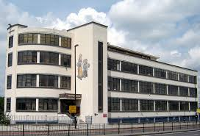

On Carpenters Road, just on the other side of the railway is a building that was originally used as a factory but during World War 1 it became a German internment camp, holding 750 Germans, Austrians and Turks. The people living on the road at the time were not aware of the plans to turn the building into an internment camp until the prisoners were marched down the road from Stratford station. They did not receive a warm welcome and were spat on by women and children on their parade. The camp closed just before the end of World War 1 and ironically was bombed shortly afterwards. There is more evidence of the anti-German sentiments in the area in the King Edward VII pub, formerly known as the prince of Prussia, its name changing at the beginning of the First World War.

C:\Users\RidoutFamily\Downloads\Bow Back River.tif

(River Lea Clip)

(Through the tunnel clip)

**Queen Elizabeth Olympic Park**

The Park covers an area of 2.5sq kms. Some prehistoric settlements have been unearthed, including 4 iron age skeletons.

In creating the Park, 2m tons of soil was cleaned, 5kms of riverbank were cleaned, power cables buried underground and an EU fridge mountain ("one of Europe's most iconic eyesores") removed. 250 ha (500 acres) of parkland were created. The north part of the Park is be more like traditional parkland. The southern section is more "urban" and can be used for events.

*The ArcelorMittal Orbit :*A 376 feet tall sculpture come observation tower, designed by Turner prize winning sculptor Sir Anish Kapoor and engineer Cecil Balmond . It is said to be inspired by the Tower of Babel. As a late addition to the Olympic Park, it was mostly paid for by Lakshmi Mittal.

*The Aquatic Centre;* Designed by Zaha Hadid Architects. Zaha Hadid was a Bagdad born and London trained architect of world repute, but who has completed few UK buildings. Another is the recent extension to the Serpentine Gallery. The Aquatic Centre uses her trademark curves, and is said to be inspired by water in motion. Whatever its inspiration the roof presented an engineering challenge. The building was in fact designed before the Olympic bid was successful and therefore had to have extra seating wings added for the Games. Reputedly the Centre cost £50m more than the original budget of £249m. It has been funded to be run by Greenwich Leisure.

*The Copper Box:* The Handball Arena during the Olympic Games, this venue was designed by MAKE architects and uses recycled copper for its cladding. Now a leisure centre, run, like the Aquatic Centre by Greenwich Leisure. It has seating for up to 7,000 and is the new home of the London Lions Basketball Team. It also hosts a Grand Prix Badminton tournament.

*The Velodrome:* A hyperbolic paraboloid-shaped steel framed structure sits on a 360 degree glazed concourse, the whole being clad in timber to allow natural ventilation. Designed by Hopkins architects it was the first completed venue for the Olympics. it had seating for 6000 during the Games. Now the centrepiece of cycling facilities including outside road, BMX and mountain bike courses and has been taken over by the Lea Valley Regional Park Authority.

*The Energy Centre (not in Newham):* Providing heating and cooling for the games and district heating as a legacy, plus providing power to the national grid. They utilises Combined Cooling Heat and Power systems with biomass boilers. Designed by John McAslan and Partners they utilise a rusty facade.

*Stratford Box Pumping Station:*

Lyall Bills & Young’s Stratford Box Pumping Station in the Queen Elizabeth Olympic Park is said to be at once sculptural, enduring and integrated into the landscape. It was built to relieve groundwater build-up caused by changes in the water table, avoiding flooding of the Eurostar/HS1 line.

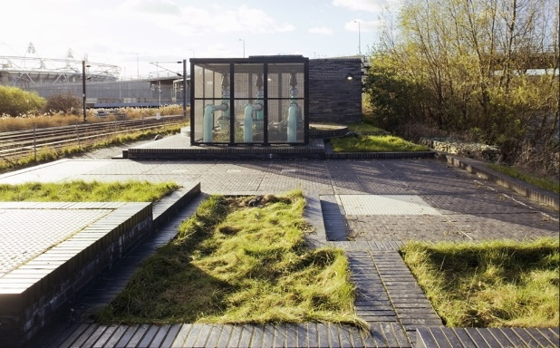

**Stop 2 Bow Flyover**

**Old Ford and Bow Bridge**

Old Ford, as the name suggests, was the ancient most downstream crossing point of the [River Lea](https://en.wikipedia.org/wiki/River_Lea). Now crossing between Tower Hamlets and Hackney. In 1110, [Matilda](https://en.wikipedia.org/wiki/Edith_of_Scotland), wife of [Henry I](https://en.wikipedia.org/wiki/Henry_I_of_England), reputedly took a tumble at the ford on her way to [Barking Abbey](https://en.wikipedia.org/wiki/Barking_Abbey) and ordered a distinctively bow-shaped three-arched bridge to be built over the [River Lea](https://en.wikipedia.org/wiki/River_Lea). which in 1838-39 was replaced by a bridge of one oblate arch at a cost of £11,000.

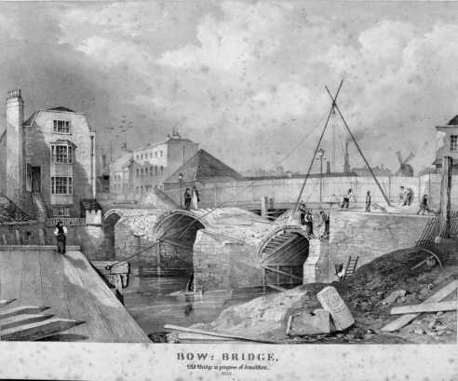

Bow Bridge during demolition

Bow Creek is situated on the final 2.5km long stretch of the river, is the final stretch of the River Lea, which rises in Luton, Bedfordshire.

As the Creek is tidal, its depth is very shallow at low tide and unnavigable at low tide. Stratford Langthorne Abbey was responsible for the maintenance of tidal waters. The earliest written evidence of the use of the river for transport and infrastructure is from an act of parliament dated 1571, that empowered the Mayor of London to make improvements to the river to allow for sufficient imports of grain.

*(Lighterrmen on the Lea Clip) as will be quiet*

*C:\Users\RidoutFamily\Downloads\Three Mills River from Groves Bridge.tif*

**Stratford Langthorne Abbey**

In 1135 William de Montfitchet, successor to Robert Gernon, founded the Cistercian abbey of Stratford Langthorne about ½ m. south of what is now Stratford High Street. Among the abbey's earliest endowments was Woodgrange, an outlying farm on the edge of the forest, first mentioned in 1189. Stratford became a rich and important house, often visited by royalty, especially in the 13th and 14th centuries, and probably used as an administrative centre for south-west Essex. It steadily enlarged its estates in West Ham, and by the 15th century controlled most of the parish. The abbey precincts, beside the Channelsea, included a few industrial buildings and private dwellings as well as the conventual buildings; but the Cistercian tradition of isolation was not without effect, for Stratford Abbey, unlike those of Barking and Waltham Holy Cross, did not attract settlement outside its walls.

The Abbey was supressed in 1538. The deed of surrender of the Abbey, which still exists in the “Public Record Office” in London, was executed in the Chapter House of the Abbey on the 18th March 1538, it was signed by William Huddleston, the last of the Abbots, the Chanter, the Sacrist and eleven monks.

Over the years, the Abbey buildings were dismantled and their materials used to build other structures in the area. You can therefore only see some remains of the **12th century abbey gatehouse** in West Ham at [Abbey Gardens](http://www.abbeygardens.org/). The gardens surround part of the abbey ruins. The Victorians used the site for part of the North Woolwich railway track and built factories on the free space.

Since the 1970s, there have been periodic archaeological digs on the site, usually during redevelopment projects in the area. These digs have helped archaeologists better understand the layout of the abbey. A series of over 600 burial excavations at Stratford Langthorne is thought to be the largest example from a Cistercian monastery in all of Europe.

A series of archaeological investigations by Museum of London of two adjoining sites in West Ham revealed remains of the wealthy medieval abbey of St Mary Stratford Langthorne (founded in 1135). The sites, at Abbey Gardens, Bakers Row and Abbey Road Docklands Light Railway Station, were investigated by the Museum between 2007 and 2010.

Among the abbey remains uncovered during the excavations were parts of the great drain, a foundation and a grave on the site of the church, a cellar or a small fishpond and possibly part of the infirmary, while planting pits provided evidence for monastic gardens on the eastern edge of the abbey precinct. However, the archaeological highlight was undoubtedly a community excavation carried out by local residents on an overgrown plot of wasteland on the north side of Bakers Row (now Abbey Gardens). The dig was organized by [Newham Council](http://www.newham.gov.uk/Pages/index.aspx)and Museum of London Archaeology with the aim of uncovering the remains of a medieval stone building first discovered by archaeologists in the early 1970s, but then reburied for their protection. It was hoped that after consolidation, the masonry would be robust enough for permanent display.

When first discovered, the building was thought to be the abbey gatehouse or Great Gate, which after the Dissolution was converted into a dwelling and survived until about 1825. However, the building was soon reinterpreted as an abbey guesthouse, for it appeared to be too small to be the gatehouse, and in any case it did not seem to straddle the access road to the abbey (perpetuated today by Bakers Row).

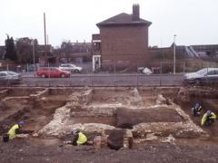

Work in a previously unexcavated strip on the south side of the medieval building revealed stone walls extending out towards Bakers Row. From this it was clear that the building was much larger than had been thought, and that it had been constructed in two phases. It was also evident that the building would have crossed the line of the access road to the abbey precinct. So it was the gatehouse after all.

After the Dissolution the gatehouse was further extended and modified for use as a secular dwelling. Brick cesspits were built next to it in the 16th/mid-17th century and the mid-17th/18th century. A stretch of the great drain was rebuilt on a smaller scale, possibly in the late 16th or 17th century, and continued in use into the 19th century. Other post-medieval features included several 16th- to 18th-century pits, the remains of a 17th-century brick building, garden walls, a possible well, moat fills and a late 18th-century/early 19th-century brick cesspit possibly associated with the converted gatehouse. The latest features were the remains of Victorian terraced houses fronting onto Bakers Row.

**All Saints West Ham Parish Church** displays a stone window and a carving from the original monastery. You can also see an example of the abbey’s coat of arms in Stratford on the Old Court House doorway.

**Stop 3 Three Mills**

The Three Mills are some of the earliest examples of a tidal mill system in Britain. They were acquired by Stratford Longthorne Abbey in the 12th century. Prior to the abbey, there is evidence in the Doomsday book of eight or nine mills situated on the same site.

During the period of dissolution of the Abbey the mills were producing flower for the bakers of Stratford-atte-bow. During the 16th century the three mills were reduced to two, the ‘House Mill’ and the ‘Clock Mill’, with production shifting to the grinding of grain used in the distillation of alcohol to produce gin. The House Mill was rebuilt in 1776 following a fire and is now a Grade 1 listed building, built for James Bisson.

The Clock Mill was rebuilt in 1815-17 by Philip Metcalfe who was a Tory MP and owner of Metcalfe and Co, a distillery based in West Ham.

**C:\Users\RidoutFamily\Downloads\Three Mills fireworks company, c 1900.tif**

The Mills would change ownership frequently until 1872 when they were purchased by distillers J & W Nicholson and Clerkenwell, and continued in operation until closure during the 2nd world war, in 1941. The mills were bombed during the war, the Millers House was totally destroyed and only rebuilt in 1995.

The Mills remain the largest tidal mills in the world, but are not in operation, the building is owned by the House Mill Trust and is one of only four Grade 1 listed buildings in Newham.

The Mills share the island with Three Mills studios, formerly known as Bow studios during the 1980s, in 2004 the London Development agency acquired 3 Mills Studios, the ownership was transferred to the LDDC in 2010. Some of the more famous films that have been produced at three mills are: Fantastic Mr Fox, Lock Stock and two smoking barrels and Made in Dagenham.

*(Three Mills sound clips 1 & 2)*

**C:\Users\RidoutFamily\Downloads\Old Ford Lock 1950.tif**

**Stop 4 Memorial Gardens**

Located in the area of the Bromley Gas Works, this garden includes the memorial to Sir Corbet Woodall, the Governor of the Gas Light and Coke Company from 1906 to 1916. From Liverpool he followed his fathe rinto the coal gas industry working at Woolwich, Stockton-on-Tees and Vauxhall before becoming a consultant gas engineer. When he became a director of the Gas

Light and Coke Company it was the largest gas company in the world. It had been

founded by Royal Charter in 1812 and was the first company to supply coal gas in

London, operated the first gas works in the United Kingdom and was the world's first

public gas works. Its first works were located at the Royal Mint. The Company was capitalised £1 million for 80,000 shares, which approximates to 7 billion in modern currency.

The company absorbed numerous smaller companies such as the Aldgate Gas light and Coke Company, the City of London Gas light and Coke Company. It eventually ended up supplying an area from Pinner in North West London to Southend on Sea, it was nationalised in 1948 under the Gas Act and became one of twelve large regional gas boards. The gas boards were replaced by British Gas, in 1972.

Sir Corbett Woodall was famed for fostering good relations with his staff and was honorary colonel of the 12th Battalion of the London Regiment. He retired to the south of France in 1914 and died 2 years later. The statute is by George Arthur Walker. They ae accompanied by war memorials and a lit gas light.

The statue (which was moved from Beckton in 1926) and war memorial are Grade II listed.

(*Gas Works and The Canal clips*)

*Institute of Mechanical Engineers Obituary 1916*

*Sir CORBET WOODALL, D.Sc., was born in Liverpool on 27th August 1841, and was educated at the Crescent School in that city.*

*His early knowledge of gas manufacture was obtained under his brother*[*William*](https://www.gracesguide.co.uk/William_Woodall)*, who was at that time manager of the*[*Burslem Gasworks*](https://www.gracesguide.co.uk/index.php?title=Burslem_Gasworks&action=edit&redlink=1)*, but he served his apprenticeship to the late*[*Mr. Robert Morton*](https://www.gracesguide.co.uk/Robert_Morton_(1834-1911))*at the works of the*[*Woolwich Equitable Gas Co.*](https://www.gracesguide.co.uk/Woolwich_Equitable_Gas_Light_and_Coke_Co)*, where he became Mr. Morton's assistant.*

*In 1865 he obtained the position of gas engineer to the Corporation of Stockton-on-Tees, and while in their service he carried out the enlargement and reconstruction of the gasworks. While at Stockton he was consulting engineer to several companies in the district, and erected the works of the*[*North Ormesby Gas Co*](https://www.gracesguide.co.uk/index.php?title=North_Ormesby_Gas_Co&action=edit&redlink=1)*.*

*He left Stockton in 1869 and returned to London to enter the service of the*[*Phoenix Gas Co.*](https://www.gracesguide.co.uk/Phoenix_Gas_Co)*, at their Vauxhall Works, of which Mr. Morton was then engineer.*

*On Mr. Morton being appointed chief engineer of the*[*London Gaslight Co.*](https://www.gracesguide.co.uk/London_Gas_Co)*at Nine Elms, his former assistant was chosen as his successor at Vauxhall. This position he held until the amalgamation of the Company with the*[*South Metropolitan Gas Co.*](https://www.gracesguide.co.uk/South_Metropolitan_Gas_Co)*, when he gave up the active management of gasworks.*

*In 1880 he commenced practice as a consulting engineer in Westminster; the practice rapidly increased, and there were few arbitration, Parliamentary, or other proceedings in connexion with gas undertakings of any importance in which he or his firm were not retained as advisers.*

*From 1882 to 1900 he was in partnership with the late*[*Mr. Edward B. Ellington*](https://www.gracesguide.co.uk/Edward_Bayzand_Ellington)*as regards hydraulic power matters.*

*He attained the highest position in the gas industry of the world when, early in 1906; he succeeded*[*Sir William T. Makins*](https://www.gracesguide.co.uk/index.php?title=William_T._Makins&action=edit&redlink=1)*, Bart., as Governor of the*[*Gas Light and Coke Co*](https://www.gracesguide.co.uk/Gas_Light_and_Coke_Co)*. At that time the Company was making one-eighth of the gas supplied to Great Britain, and by the beginning of 1912, mainly through his instrumentality, the price of gas had been reduced by 5d. per 1000 cubic feet to 2s. 6d., at which it remained until war conditions compelled an increase.*

*Two features in connexion with his tenure of this position stand out prominently, namely, the introduction of co-partnership and the formation of a corps of Territorials. The scheme of co-partnership has justified its adoption, and other companies with whirls he was connected have also adopted the system.*

*He also introduced, in association with the London County Council, a scheme for the training of lads as gas-fitters, and another effort to produce competent workmen was the establishment of weekly lectures to the employees engaged in fitting and outdoor work.*

*In 1913 he received the honour of knighthood by the King, and in the previous year the University of Leeds bestowed upon him the honorary degree of Doctor of Science.*

*He was, from 1911, a Justice of the Peace for the Bromley Division of Kent.*

*His death took place at Torquay on 17th May 1916, in his seventy-fifth year. He was elected a Member of this Institution in 1882, and was a Member of the Institution of Civil Engineers.*

*He was a Member of the British Association of Gas Managers, of which he became President in 1878; and he was President of the Institution of Gas Engineers in 1913, the jubilee year of the organization.*

**Stop 5 : CODY DOCK**

Originally built in the 1870’s as a dock bringing coal to the Bow Gasworks, it was developed by the Imperial Gas and Light Coke Co (later taken over by the Gas Light and Coke Company). After falling into disuse and being used as an informal dump, it was acquired by the Gasworks Dock Partnership as a Social Enterprise with a vision to provide employment, educational and cultural facilities - particularly the creative arts. Its first open day was July 2012.

The name "Cody" for the dock and the nearby road derives from the fact that "Buffalo Bill" Cody pitched his camp in the area when he was giving shows in London. It is a key site for opening up the Lower Lea Valley to walkers and cyclists. It is being re-developed as part of a community project, into a working marina, under the Cody wilds project. The project is being led by the Gasworks Dock Partnership. The aim of the development is to deliver a sustainable creative industry hub, promote community value and increase participation in the arts and access to the diverse ecology of the river Lea for local community groups.

C:\Users\RidoutFamily\Downloads\Bow Creek.tif

**Stop 6 Lower Lea Crossing**

*Thames Ironworks*

The Thames Ironworks and Shipbuilding Company, Limited was a [shipyard](https://en.wikipedia.org/wiki/Shipyard) and [iron works](https://en.wikipedia.org/wiki/Iron_works) straddling the mouth of [Bow Creek](https://en.wikipedia.org/wiki/Bow_Creek_(England)) at its confluence with the [River Thames](https://en.wikipedia.org/wiki/River_Thames), at [Leamouth Wharf](https://en.wikipedia.org/wiki/Leamouth) (often referred to as [Blackwall](https://en.wikipedia.org/wiki/Blackwall,_London)) on the west side and at [Canning Town](https://en.wikipedia.org/wiki/Canning_Town) on the east side. Its main activity was [shipbuilding](https://en.wikipedia.org/wiki/Shipbuilding), but it also diversified into civil engineering, marine engines, cranes, electrical engineering and motor cars

Mao circa 1872 showing Victoria Docks, Bow Creek and Thames ironworks and Ship Company

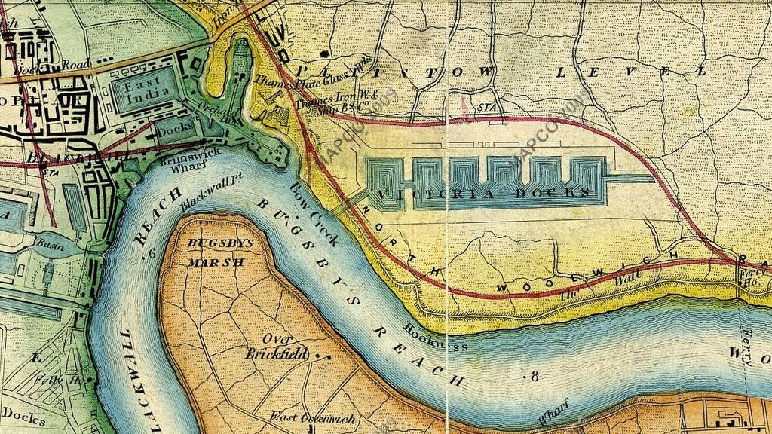

In 1838 the Dichburn and Mare Shipbuilding Company moved to Orchard Place from Deptford taking over a defunct shipyard. This company was among the first building iron ships in the area.

In 1847, Mare (who continued the company after aft the retirement of Ditchburn, bought a site at Canning Town, with a ferry service operating between the two. He constructed a yard with furnaces and rolling mills. In 1853 the company launched the [SS Himalaya](https://en.wikipedia.org/wiki/HMS_Himalaya) for the [Peninsular and Oriental Steam Navigation Company](https://en.wikipedia.org/wiki/Peninsular_and_Oriental_Steam_Navigation_Company), briefly the world's largest passenger ship before becoming a naval [troopship](https://en.wikipedia.org/wiki/Troopship). In 1855 despite a full order book Ditchburn became bankrupt. The company was kept going by creditors and Mare’s father-in law, Peter Rolt and became the Thame s Ironworks and Shipbuilding and Engineering Company in 1857.

The new company was the largest shipbuilder on the Thames, its premises described by the [Mechanics' Magazine](https://en.wikipedia.org/wiki/Mechanics%27_Magazine) in 1861 as "Leviathan Workshops". Large scale [Ordnance Survey](https://en.wikipedia.org/wiki/Ordnance_Survey) maps of the 1860s show the yard occupying a large triangular site in a right-angled bend on the east bank of Bow Creek with the railway to Thames Wharf on the third side, and with a smaller site on the west bank. The main yard had a quay 1,050 feet (320m) long.[[7]](https://en.wikipedia.org/wiki/Thames_Ironworks_and_Shipbuilding_Company#cite_note-7) To the south-east the yard occupied the north bank of the Thames east of Bow Creek, with two slips giving direct access to the main river. Today the site is crossed by the [A1020](https://en.wikipedia.org/wiki/A1020_road)Lower Lea Crossing and the [Docklands Light Railway](https://en.wikipedia.org/wiki/Docklands_Light_Railway) south of [Canning Town station](https://en.wikipedia.org/wiki/Canning_Town_railway_station).

By 1863 the company had the capacity to build 25,000 tons of warships and 10,000 tons of [mail steamers](https://en.wikipedia.org/wiki/Mail_steamer) simultaneously. One of its first [Admiralty](https://en.wikipedia.org/wiki/Admiralty) contracts was for [HMS Warrior](https://en.wikipedia.org/wiki/HMS_Warrior_(1860)), launched in 1860, at the time the world's largest warship and the first iron-hulled armoured [frigate](https://en.wikipedia.org/wiki/Frigate). [HMS Minotaur](https://en.wikipedia.org/wiki/HMS_Minotaur_(1863)) followed in 1863, 400 feet (120 m) long and 10,690 tons displacement.

Work on vessels such as Minotaur was performed on the Canning Town side of the Lea, and this is where the Thames Ironworks expanded from less than 10 acres (4.0 ha) in 1856 to 30 acres (12 ha) by 1891. While the old site at Orchard Place was still the company's official address until 1909, its presence there was minimal, by the late 1860s the company having only a 5 acres (2.0 ha) site there.

In 1895 Managing Director and philanthopist Arnold Hills set up a football club for the works’ employees.

Warships being built on the eastern site circa 1902.

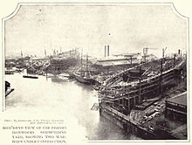

During its lifetime the yard produced 144 warships and numerous other vessels.

1898 launch of HMS Albion was captured on film & is available on [you tube](https://www.youtube.com/watch?v=me2DF4J85Ak). Tragedy struck when she was launched on 21 June 1898;[[3]](https://en.wikipedia.org/wiki/HMS_Albion_(1898)#cite_note-3) after the [Duchess of York](https://en.wikipedia.org/wiki/Duchess_of_York) christened her, a wave created by *Albion*'s entry into the water caused a stage from which 200 people were watching to collapse into a side creek, and 34 people, mostly women and children, drowned in one of the worst peacetime disasters in Thames history.

In 1911 Hills petitioned [Winston Churchill](https://en.wikipedia.org/wiki/Winston_Churchill), then [First Lord of the Admiralty](https://en.wikipedia.org/wiki/Lord_Commissioner_of_the_Admiralty), regarding the lack of new orders. He was unsuccessful, and the yard was forced to shut in 1912.[[2]](https://en.wikipedia.org/wiki/Thames_Ironworks_and_Shipbuilding_Company#cite_note-Lewis-2) Within two years the United Kingdom was at war with the [German Empire](https://en.wikipedia.org/wiki/German_Empire), with the yard's last major ship taking part in the [Battle of Jutland](https://en.wikipedia.org/wiki/Battle_of_Jutland).

The Lower Lea crossing connects the final section of the canal with the Royal (Victoria) Docks and Silvertown. Cargo was loaded from the docks onto barges which transported it around London.

As the Docks expanded and created employment opportunities, Canning Town and the surrounding area became densely populated, but conditions of living were very poor. In 1857 Charles Dickens described the area as follows: "Canning Town is the child of the Victoria Docks. The condition of this place and of its neighbour prevents the steadier class of mechanics from residing in it. They go from their work to Stratford or to Plaistow. Many select such a dwelling place because they are already debased below the point of enmity to filth; poorer labourers live there, because they cannot afford to go farther, and there become debased. The Dock Company is surely, to a very great extent, answerable for the condition of the town they are creating. Not a few of the houses in it are built by poor and ignorant men who have saved a few hundred pounds, and are deluded by the prospect of a fatally cheap building investment.”

From the late 19th century, a large African mariner community was established in Canning Town as a result of new shipping links to the Caribbean and West Africa.

In 1917 50 tons of TNT exploded at the Brunner Mond & Co ammunition work in Silvertown, causing the largest explosion in London's history and damaging more than 70,000 buildings and killing 73 people.

C:\Users\RidoutFamily\Downloads\Canning Town Bridge, Lower Lea, 1984.tif

C:\Users\RidoutFamily\Downloads\Bow Creek 2.tif

**Stop 7 Royal Docks**

*(Canal Engineering clip)*

The Royal Docks are a collection of three docks, Royal Albert, George V and Royal Victoria. Despite being named after the monarchy, they are not owned by the royal family. They were completed between 1855 and 1921, by St Katherine’s docks company. Spanning over 12 miles, the docks were responsible for the majority of imports and exports to and from the city. As a result large granaries, warehouses and storehouses were built along the river.

Collectively the largest enclosed docks in the world, occupying a space the equivalent to the whole of central London from Hyde park to Tower Hill. Victoria Dock was built 1850-5 by the Victoria Dock Co. and designed by George Parker Bidder, a civil engineer from Devon. An advance on earlier docks by virtue of its size, its own railway system and the extensive use of finger jetties to increase capacity. By 1860 the dock was taking in 850,000 tonnes of shipping per year.

The Pontoon Dock was built towards the end of the construction of the Victoria Dock and include and included a revolutionary ship lift, which lifted each ship out of the water on pontoons that were raised by hydraulic jacks. Drained of ballast water the ship could then be floated to a finger dock for repair. By 1896 the size of ships became too great for this manoeuvre. The docks usage was shifted to grain storage as most new vessels were too large to be service in the dock.

The Albert Dock was built 1875-80, which has 85 acres of water.

The Royals were taken over by the Port of London Authority in 1909. The George V Dock was one of two planned for the north and south of the Albert Dock by an1901 Act of Parliament. It was built 1912-21, and has 64 acres of water.

During the General Strike the generators of 2 Royal Navy submarines were connected to the warehouses to save 750,000 frozen carcasses.

The docks were heavily bombed during the war, it is estimated that 25,000 tons of ordinance was dropped on the Royal Docks during the Blitz. The docks remained open despite high casualties of many dockers working during air raids. Following the war the docks briefly recovered as a commercial hub, but with the advent of the far more efficient method of containerization, which allowed cargo to be transported much easier on land, the docks eventually ceased commercial activity in 1981.

*(Connaught and Containerisation clip)*

Several of the granaries and mills were damage by the Silvertown explosion, in 1917. Many dockside buildings were demolished to prepare for a commercial development, Silvertown quays, which has not materialised.

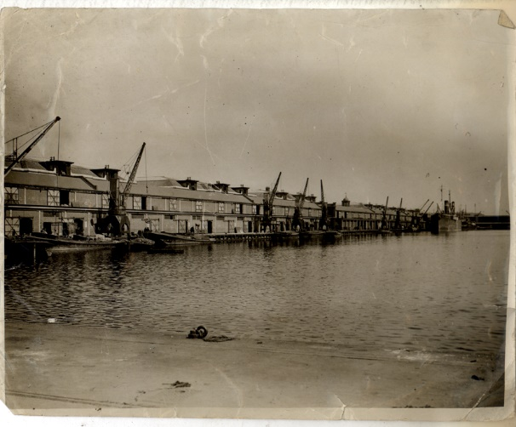

*SS Robin*

The world's oldest complete steamship, this ship was built in 1890 at the Thames Ironworks. She was used mostly for British coastal trade to 1900, then was sold to Spain and used for Atlantic trade until 1974. She was bought by the Maritime Trust in 1974 and will become a "innovative and immersive environment as well as a performing stage, with dedicated learning spaces and interactive displays sharing the stories of dockers, stevedores and seafarers who worked across oceans and ships such as this and celebrating the risks takers and entrepreneurs that made, and continue to make, London great."



*(Silvertown Explosion clip)*

**Stop 8 Memorial Ground**

West Ham station was opened in 1901 and on the Fenchurch St – Barking line, opened in 1858. The station was renovated in 1999 and 2006, the station was renovated extensively for the London Olympics.

*West Ham United*

In 1855, the Thames Ironworks company had more than 3000 employees.

The 1895? FA Cup Final before 42,560 spectators created a sensation and David Taylor, the foreman of the shipbuilding department of [Thames Ironworks](http://www.portcities.org.uk/london/server/show/ConNarrative.59/Thames-Ironworks.html), suggested to [Arnold Hills](http://spartacus-educational.com/WHhillsA.htm), that maybe the company should form its own football club. On 29th June, 1895, Hills announced in his newspaper, the Thames Ironworks Gazette, that he intended to establish a football club. Mr. Hills' initial concept was for a purely amateur team for the benefit of works employees. Each who wished to take part paid an initial annual stipend of 2s/6d.

e site of the 1st Ground (Hermit Road in Canning Town) 1895-1896  
Thames Ironworks had taken over the tenancy of a ground in Hermit Road in the summer of 1895 from Old Castle Swifts F.C., who were the first professional football club in Essex. The Hermit Road ground had been described as a 'cinder' heap' and 'barren waste'. It was surrounded by a moat.  
  
Thames Ironworks played their first ever fixture of the 1895-96 season against Royal Ordnance reserves in September 1895, the game ending 0-0. In Thames' first competitive game, they took on Chatham in a preliminary qualifying round of the FA Cup. The match had to be played at Chatham's ground in Kent as they had rated the Irons' Hermit Road Ground as unsuitable.

They joined the [London League](https://en.wikipedia.org/wiki/London_League_%28football%29) in 1896, finishing runners-up after only gaining entrance due to the withdrawal of the [Royal Ordnance Factories F.C.](https://en.wikipedia.org/wiki/Royal_Ordnance_Factories_F.C.).  
  
The early years saw an experimental 'floodlit friendly' in Thames' first encounter with Woolwich Arsenal. The pitch was surrounded by light bulbs attached to poles. The football was dipped in pails of whitewash to make it easier to see.   
  
The last game at Hermit Road was in October 1896, when Thames Ironworks beat 1st Scots Guards 1-0. Later that month they were handed an eviction notice from Hermit Road by their landlords. The club had violated their tenancy agreement by charging admission fees and building a perimeter fence and pavilion. Thames Ironworks had to play their next four fixtures at the grounds of their opponents, until a new home could be found.

At the turn of 1897,  the club managed to lease a temporary piece of land for the team, located in Browning Road, East Ham but this was only for a couple of months.The new situation was not ideal, so Hills earmarked a large section of land in [Canning Town](https://en.wikipedia.org/wiki/Canning_Town) for a new stadium to be built upon. The new home cost [£](https://en.wikipedia.org/wiki/Pound_sterling)20,000 of [Arnold Hills](https://en.wikipedia.org/wiki/Arnold_Hills)' own money to build.

The Memorial Grounds was opened on Jubilee Day, 22 June 1897, to coincide with the sixtieth anniversary of [Queen Victoria](https://en.wikipedia.org/wiki/Queen_Victoria)'s [coronation](https://en.wikipedia.org/wiki/Coronation). Aside from a football pitch, the stadium contained a cycle track, a cinder running track, tennis courts and one of the largest outdoor swimming pools in [England](https://en.wikipedia.org/wiki/England). It was said at the time that the grounds, with a capacity of 100,000 spectators, were "good enough to stage an English Cup Final."

On 11 September 1897, in their first game at their new ground, Thames beat [Brentford](https://en.wikipedia.org/wiki/Brentford_F.C.) 1-0. In West Ham United's first game at the grounds in front of 2,000 spectators, in the [Southern League](https://en.wikipedia.org/wiki/Southern_Football_League) on 1 September 1900, they won 7-0 against, [Gravesend United](https://en.wikipedia.org/wiki/Gravesend_United_F.C.), with [Billy Grassam](https://en.wikipedia.org/wiki/Billy_Grassam) scoring four.

It was becoming increasingly difficult to persuade men to play for the team. A major problem was the fear of an injury that would result in them being unable to work for the [Thames Iron Works Company](http://www.portcities.org.uk/london/server/show/ConNarrative.59/Thames-Ironworks.html). The club committee therefore decided to insure the players against loss of wages that might follow an injury sustained during league and cup fixtures. However, the club committee issued the players with a warning that anyone who had been injured in a match had to be home by 8.p.m. every evening. They were obviously concerned that they did not try to ease the pain by spending their time drinking in the local public houses.

In November 1897 [Arnold Hills](https://en.wikipedia.org/wiki/Arnold_Hills) secured an agreement with [London, Tilbury and Southend Railway](https://en.wikipedia.org/wiki/London,_Tilbury_and_Southend_Railway) (LT&SR) to build a station at Manor Road. The LT&SR board approved this in February 1898 and Mowlem's was given the contract to build a four platform station, allowing for the proposed quadrupling of the line. The station was completed in May 1900 but did not open until 1 February 1901 as [West Ham](https://en.wikipedia.org/wiki/West_Ham_station)

In June 1900, Thames Ironworks was wound up but was immediately relaunched on 5 July 1900 as West Ham United Football Club,

The reborn club played their games at the [Memorial Ground](https://en.wikipedia.org/wiki/Memorial_Grounds) (rented at favourable terms by Arnold Hills who was a major shareholder in the new club). In the 1901–02 season, the team did well on the field and made a small profit. In the 1902–03 season, the directors were shocked by a loss of £151 that was caused by a wage bill that had gone up by 50 percent. The 1903–04 season saw an even greater loss, at £793, caused by the loss of season ticket income from supporters because the club had become more distant from the workers at the ironworks and with fewer local players being employed. At the beginning of the 1904–05 season, the directors were looking to move to the Boleyn Castle, a site of a Catholic school surrounded by small shops and residential streets, everything the Memorial Grounds did not have.

The new ground was originally named "The Castle" for the 1904–05 season (a local pub in Plaistow to this day is called "The Castle") sited on a plot of land near Green Street House. The original gates to the ground, with the original Hammers crest (now painted in claret and blue), can be seen in Grange Road, London E13.

The club rented [Green Street](https://en.wikipedia.org/wiki/Green_Street,_London) House and grounds in the [Municipal Borough of East Ham](https://en.wikipedia.org/wiki/County_Borough_of_East_Ham) from the Roman Catholic Church from around 1912.The House was known locally as Boleyn Castle because of its imposing nature and an association with [Anne Boleyn](https://en.wikipedia.org/wiki/Anne_Boleyn), who had either stayed at or, as some believe, owned the house. Hence renting the grounds of "Boleyn Castle" the name Boleyn Ground came into being.

In August 1944, a [V-1 flying bomb](https://en.wikipedia.org/wiki/V-1_flying_bomb) fell on the south-west corner of the pitch. This forced the team to play its games away from home while repairs were undertaken, but it did not affect performances as West Ham managed nine consecutive victories. Upon their return to the ground in December, they lost 1–0 to [Tottenham Hotspur](https://en.wikipedia.org/wiki/Tottenham_Hotspur).

**Stop 9The Greenway and Abbey Mills**

The Greenway was constructed on the Northern Outfall sewer, which itself was built as a response to the ‘Great Stink’ of July and August 1858 which had been preceded by outbreaks of cholera. By June that year the stench from the river had become so bad that business in [Parliament](https://en.wikipedia.org/wiki/Palace_of_Westminster) was affected, and the curtains on the river side of the building were soaked in lime chloride to overcome the smell. The Great stink was a result of the increasing pollution of London’s rivers including by the introduction of flush toilets, over filling the drainage system that was only designed to keep rainwater.

It was built by Joseph Balgazette, part of a 1,300 mile network of sewage pipeline as 5 interceptor sewers, three of which were built by Balgazette. The Greenway lies on top of this network which is 7.1 kilometres long, or 4.4 miles from Victoria Park to Beckton.

Abbey Mills Pumping station was designed by Joseph Bazalgette with architect Charles Driver in a cruciform Byzantine style, "the cathedral to sewage" was built in1868. It is a Grade II listed building. From here sewage was pumped between two low level sewers and the Northern Outfall Sewer. It contains electric pumps now to back up the modern facility.

The modern pumping station was designed by Allies and Morrison.

During the Second World War, two A/A guns were positioned on the sewer bank, and a pillbox, which still remains.

Towards the end of the Greenway, by the East London cemetery is an archway known as the Devil’s Canyon’, it’s a disused railway arch possibly built on an earlier cemetery, under which lie broken gravestones.

(Greenway clip)

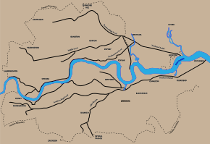

Bazalgette’s sewer system for London

