West Ham United Heritage Ride

Thames Ironworks
The Thames Ironworks and Shipbuilding Company, Limited was a shipyard and iron works straddling the mouth of Bow Creek at its confluence with the River Thames, at Leamouth Wharf (often referred to as Blackwall) on the west side and at Canning Town on the east side. Its main activity was shipbuilding, but it also diversified into civil engineering, marine engines, cranes, electrical engineering and motor cars

Map circa 1872 showing Victoria Docks, Bow Creek and Thames ironworks and Ship Company
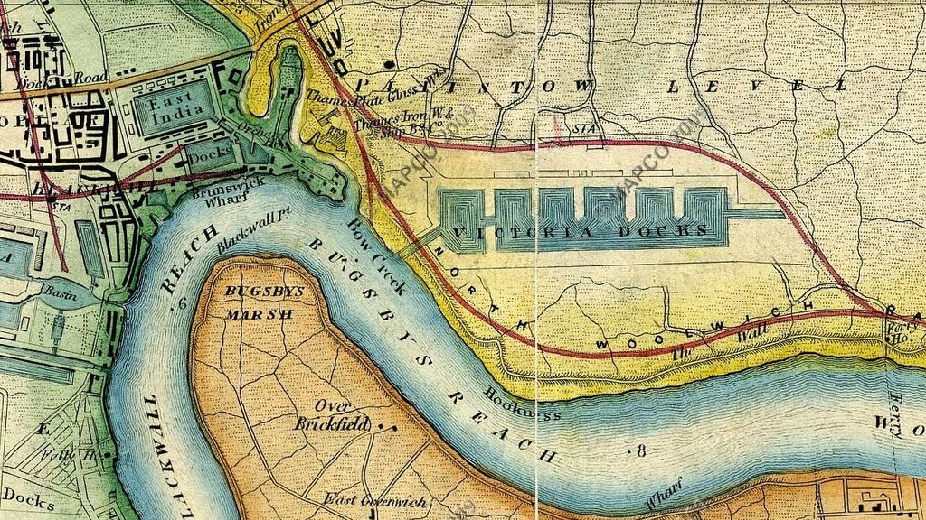

In 1838 the Dichburn and Mare Shipbuilding Company moved to Orchard Place from Deptford taking over a defunct shipyard. This company was among the first building iron ships in the area.

In 1847, Mare (who continued the company after aft the retirement of Ditchburn, bought a site at Canning Town, with a ferry service operating between the two. He constructed a yard with furnaces and rolling mills. In 1853 the company launched the SS Himalaya for the Peninsular and Oriental Steam Navigation Company, briefly the world's largest passenger ship before becoming a naval troopship. In 1855 despite a full order book Ditchburn became bankrupt. The company was kept going by creditors and Mare’s father-in law, Peter Rolt and became the Thame s Ironworks and Shipbuilding and Engineering Company in 1857.

The new company was the largest shipbuilder on the Thames, its premises described by the Mechanics' Magazine in 1861 as "Leviathan Workshops". Large scale Ordnance Survey maps of the 1860s show the yard occupying a large triangular site in a right-angled bend on the east bank of Bow Creek with the railway to Thames Wharf on the third side, and with a smaller site on the west bank. The main yard had a quay 1,050 feet (320m) long.^{[7]} To the south-east the yard occupied the north bank of the Thames east of Bow Creek, with two slips giving direct access to the main river. Today the site is crossed by the A1020Lower Lea Crossing and the Docklands Light Railway south of Canning Town station.

By 1863 the company had the capacity to build 25,000 tons of warships and 10,000 tons of mail steamers simultaneously. One of its first Admiralty contracts was for HMS Warrior, launched in 1860, at the time the world's largest warship and the first iron-hulled armoured frigate. HMS Minotaur followed in 1863, 400 feet (120 m) long and 10,690 tons displacement.

Work on vessels such as Minotaur was performed on the Canning Town side of the Lea, and this is where the Thames Ironworks expanded from less than 10 acres (4.0 ha) in 1856 to 30 acres (12 ha) by 1891. While the old site at Orchard Place was still the company's official address until 1909, its presence there was minimal, by the late 1860s the company having only a 5 acres (2.0 ha) site there.

In 1895 Managing Director and philanthopist Arnold Hills set up a football club for the works’ employees.

Warships being built on the eastern site circa 1902.

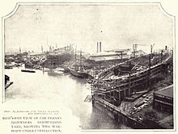

During its lifetime the yard produced 144 warships and numerous other vessels.

1898 launch of HMS Albion was captured on film & is available on you tube. Tragedy struck when she was launched on 21 June 1898; after the Duchess of York christened her, a wave created by Albion's entry into the water caused a stage from which 200 people were watching to collapse into a side creek, and 34 people, mostly women and children, drowned in one of the worst peacetime disasters in Thames history.

In 1911 Hills petitioned Winston Churchill, then First Lord of the Admiralty, regarding the lack of new orders. He was unsuccessful, and the yard was forced to shut in 1912.^{[2]} Within two years the United Kingdom was at war with the German Empire, with the yard's last major ship taking part in the Battle of Jutland.

Football –Hermit Rd
In 1895 Managing Director and philanthropist Arnold Hills set up a football club for the works’ employees. His initial concept was for a purely amateur team for the benefit of works employees. Each who wished to take part paid an initial annual stipend of 2s/6d.

Thames Ironworks had taken over the tenancy of the ground in the summer of 1895 from Old Castle Swifts F.C., who were the first professional football club in Essex, but had collapsed The Hermit Road ground had been described as a 'cinder' heap' and 'barren waste'. It was surrounded by a moat (a possible exaggeration) and initially had canvas sheeting for fencing. This is controversial, given that the Old St.Luke’s club had been residents since 1892, before amalgamating with Castle Swifts for the 1894/95 season.

The whole ground was intended to be used for a variety of sports, one of which included the cycling club, which had been inaugurated in June 1894, but had no cycle track for competitive use. A track of 360 yards circumference and six yards two inches wide was laid out by members in June 1895.

Thames Ironworks played their first ever fixture of the 1895-96 season against Royal Ordnance reserves in September 1895, the game ending 0-0 (or 1-1). In Thames' first competitive game, they took on Chatham in a preliminary qualifying round of the FA Cup . The match had to be played at Chatham's ground in Kent as they had rated the Irons' Hermit Road Ground as unsuitable. Chatham won 5-0.
March 1896 saw an experimental 'floodlit friendly' in Thames' first encounter with Woolwich Arsenal. These early attempts at floodlighting were set up using Thames Iron Works engineers and equipment, and caused an amount of notoriety. They were also used for "The Irons" next game, in their first ever meeting with West Bromwich Albion, which they lost 2-4.

Thames Ironworks were admitted to the London League for the 1896/97 season – perhaps no surprise when you learn that Thames Ironworks managing director Arnold Hills was president of the competition.

The Club hosted their first-ever league fixture on 19 September 1896, when Crouch End-based Vampires were vanquished 3-0 thanks to two goals from debutant centre-half EG Hatton and one from ship’s plater and inside forward George Gresham.
Thames Ironworks’ second league match at Hermit Road would also be their last.
On 8 October, they beat 1st Scots Guards 1-0. Later the same month, they were handed an eviction notice by their landlords. The club had violated their tenancy agreement by charging admission fees and building a perimeter fence and pavilion.
Thames Ironworks had to play their next five fixtures away from home, including an 8-0 FA Cup defeat at Sheppey United, until the Club’s management found a new home at Browning Road in East Ham in early 1897.
Browning Road (corner of Byron Rd)

At the turn of 1897, Arnold Hills, managed to lease a temporary piece of land for the team at the junction of Byron Avenue and Browning Road in East Ham, a huge undeveloped area back in 1896. Thames' first game at their new home came on 6 March 1897 in a 3-2 win over Ilford. However the new situation was not ideal, explained by future Ironworks player and West Ham United manager Syd King in his 1906 book:
'"For some reason, not altogether explained, the local public at this place did not take kindly to them and the records show that Browning Road was a wilderness both in the manner of luck and support." - Syd King, 'Book Of Football' (1906)
With the club's presence never likely to be permanent, chairman Arnold Hills earmarked a large piece of land in Canning Town and would eventually spend £20,000 on the construction of the Memorial Grounds. On 8 April 1897 came not only Thames Ironworks' last game of the season but their last game at Browning Road. The game against Barking Woodville ended 1-1.

Memorial Grounds

in 1897, Arnold Hills announced that he had bought a large piece of land and that he was going to build a multi-purpose sports centre at the Memorial Grounds. It was called the Memorial Grounds because it was opened on Jubilee day (22 June) 1897, which was 60 years after Queen Victoria's ascent to the throne and, as a tribute to her, he gave it that name. It was built in six months, opened in June and something like 8,000 people came along to the opening. The new home cost £20,000 of Arnold Hills' own money to build.
The ground, it was said, could take 100,000 spectators - it had a banked cycle track, which was one of the best in the London area, and the ground was believed to be fit to host an FA Cup final, although it never did. The football pitch sat in the middle of the cycle track, and there were other things here like tennis courts, cricket pitches and a swimming pool. Of course there was a stand and administrative offices too, so it was quite a fantastic centre for sport in east London.
Season tickets for the 1897-98 were fixed at 5 shillings (25p). Tickets for individual matches cost 4d. However, attendances at games were very disappointing. Only 200 people saw the first game against Northfleet. This is not surprising when you compare this with the price of other forms of entertainment. It usually cost only 3d. to visit the musical hall or the cinema. It has to be remembered that at this time skilled tradesmen usually received less than £2 a week.
On 11 September 1897, in their first game at their new ground, Thames beat Brentford 1-0. In West Ham United's first game at the grounds in front of 2,000 spectators, in the Southern League on 1 September 1900, they won 7-0 against, Gravesend United, with Billy Grassam scoring four.[1][4]
In November 1897 Arnold Hills secured an agreement with London, Tilbury and Southend Railway (LT&SR) to build a station at Manor Road. The LT&SR board approved this in February 1898 and Mowlem's was given the contract to build a four platform station, allowing for the proposed quadrupling of the line. The station was completed in May 1900 but did not open until 1 February 1901 as West Ham.

It was becoming increasingly difficult to persuade men to play for the team. A major problem was the fear of an injury that would result in them being unable to work for the Thames Iron Works Company. The club committee therefore decided to insure the players against loss of wages that might follow an injury sustained during league and cup fixtures. However, the club committee issued the players with a warning that anyone who had been injured in a match had to be home by 8.p.m. every evening. They were obviously concerned that they did not try to ease the pain by spending their time drinking in the local public houses.
In June 1900, Thames Ironworks was wound up but was immediately relaunched on 5 July 1900 as West Ham United Football Club,
When West Ham United were formed in 1900, Arnold Hills continued to support the new football club, not only with money and kit, but he allowed them to use the Memorial Grounds at a nominal rent as well. On 1 September 1900, they played their first match here in the Southern League, and they were fortunate enough to win that by seven goals to nil, and their famous Scottish inside-right Billy Grassam scored four of those goals.
In the 1901–02 season, the team did well on the field and made a small profit. In the 1902–03 season, the directors were shocked by a loss of £151 that was caused by a wage bill that had gone up by 50 percent. The 1903–04 season saw an even greater loss, at £793, caused by the loss of season ticket income from supporters because the club had become more distant from the workers at the ironworks and with fewer local players being employed. At the beginning of the 1904–05 season, the directors were looking to move to the Boleyn Castle, a site of a Catholic school surrounded by small shops and residential streets, everything the Memorial Grounds did not have.

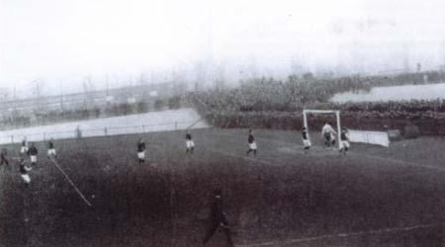
West Ham United in action at the Memorial Grounds in 1904
It was still used by the community in general after West Ham left here in 1903. For many years, up to and after the Second World War, many schools held their sports days and events like that here.

Syd King and the move to the Boleyn Ground

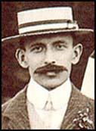
Syd King was born in Chatham in August, 1873. After being educated at Watford Grammar School he found work at an ordnance depot. A talented footballer, he played at right-back with Northfleet United in the Kent League. In 1897 he moved to New Brompton (Gillingham).
In 1899 Francis Payne, Thames Iron Works' secretary, was given the task of finding good players for the club's first season in the top division of the Southern League. According to one report, Arnold Hills, gave Payne £1,000 to find the best players available. Payne signed several players including King, who at the time was considered to be the most promising full backs in the country and Derby County, one of the best teams in England, challenged Thames Iron Works for his signature.
Over the next few years Syd King developed a good partnership with Charles Craig, a left-back from Dundee. Syd King suffered a bad ankle injury against Tottenham Hotspur on 10th March, 1899. This ruled him out for the rest of the season. King played 28 games the following season.
In the 1901-02 King was part of the highly successful West Ham United team that included players like Hugh Mounteith, Fergus Hunt, Freddie Fenton, George Radcliffe, James Reid, Albert Kaye, Billy Grassam, Charlie Dove, Roderick McEachrane, Fred Corbett, Walter Tranter and Charles Craig that finished 4th in Division 1 of the Southern League.
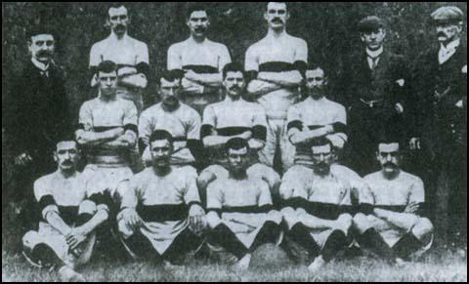Syd King (top left) in the West Ham United team of 1901-02.
Syd King, who had received a very good grammar school education, was seen as more intelligent than most players and at the end of the 1901-02 season was appointed as club secretary/manager. He continued to play but injuries restricted his appearances and he retired from the game after playing against Kettering Town on 15th April, 1903. King had played a total of 89 games for the club.
West Ham United lost their prolific scorer, Billy Grassam, to Manchester United before the start of the 1903-1904 season. Dick Pudan, a local lad from Canning Town, who had played well at full-back the previous season, left for Bristol Rovers. He later went on to play for Newcastle United in the 1908 FA Cup Final.
Syd King brought in Charles Satterthwaite from New Brompton to replace Grassam. William Kirby, a right-winger who had a good scoring record, was signed from Swindon Town. Tommy Allison was brought in from Reading to bolster the defence. Herbert Lyon, a forward, also joined from Reading. Len Jarvis, a talented local boy, was also brought into the team.
Attendances at games, compared to their close rivals, remained disappointing. One reason for this was no nearby railway station. West Ham United began to verge on the edge of bankruptcy and by the end of the season the club only had had the money to pay the wages of one professional player, Tommy Allison, during the summer.
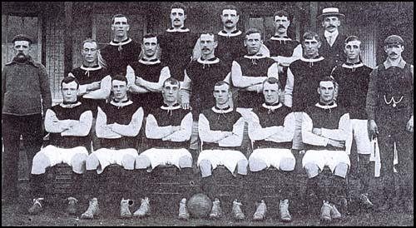
West Ham United in 1904-05: Back row (left to right): Herbert Bamlett, Aubrey Fair,Matt Kingsley, David Gardner, Syd King (manager): Middle row: Tom Robinson (trainer),Fred Brunton, Tommy Allison, Frank Piercy, John Russell, Len Jarvis, Fred Mercer,Charlie Paynter (assistant trainer). Front row: William McCartney, Charlie Simmons,Billy Bridgeman, Jack Fletcher, Christopher Carrick, Jack Flynn.
Arnold Hills was also having financial problems and was unwilling to re-negotiate a rental agreement to use the Memorial Grounds that was acceptable to West Ham United. The club was forced to find another sponsor. A local brewery agreed to advance them a loan to help them purchase a new ground.
Syd King was given the task to find West Ham a new home. It was suggested that he should take a look at Boleyn Castle field, just off Green Street, East Ham. The land was owned by the Catholic Ecclesiastical Authorities and used by the Boleyn Castle Roman Catholic Reformatory School.
A deal was arranged with the Catholic Ecclesiastical Authorities but the Home Office made it clear that they did not approve of the land being used by West Ham United. Syd King went to see Sir Ernest Gray, an influential Member of Parliament. As King later explained, "through his good offices, subject to certain conditions, we were finally allowed to take possession of Boleyn Castle.

The Boleyn Ground

The new ground was originally named "The Castle" for the 1904–05 season (a local pub in Plaistow to this day is called "The Castle"[27]) sited on a plot of land near Green Street House. The original gates to the ground, with the original Hammers crest (now painted in claret and blue), can be seen in Grange Road, London E13.

1904 also saw the introduction of the newly renamed club emblem. It incorporated the crossed hammers of the old Thames Ironworks emblem, and introduced the "castle" in the background meant to reference the fact the land they played on was home to an old Tudor castle for Anne Boleyn.

The club rented Green Street House and grounds in the Municipal Borough of East Ham from the Roman Catholic Church from around 1912.[3][not in citation given] Green Street House was known locally as Boleyn Castle because of its imposing nature and an association with Anne Boleyn, who had either stayed at or, as some believe, owned the house. Hence renting the grounds of "Boleyn Castle" the name Boleyn Ground came into being. The ground is often referred to as Upton Park, after the Upton Park, London area in which it is located.

In August 1944, a V-1 flying bomb fell on the south-west corner of the pitch. This forced the team to play its games away from home while repairs were undertaken, but it did not affect performances as West Ham managed nine consecutive victories. Upon their return to the ground in December, they lost 1–0 to Tottenham Hotspur.

When the Premier League fixtures were drawn-up at the start of the 2015-16 season, Swansea City were planned to be West Ham's final opponents at the Boleyn Ground, on 7 May 2016. However, due to Manchester United's involvement in the FA Cup on 23 April when they were due to play West Ham, the fixture was rearranged to 10 May 2016.[8] The match was proceeded by violence on Green Street when the coach carrying the players and staff of Manchester United was pelted with missiles resulting in broken windows. With the coach delayed, the players were late arriving at the ground and the scheduled 19:45 kick-off was moved to 20:15.[9]
In the 2,398th game played at the ground,[10] with both sides looking to qualify for European football in the 2016-17 season, in front of a crowd of 34,907, West Ham took the lead in the 10th minute through Diafra Sakho only for Manchester United to make the score 1-2 with two goals from Anthony Martial. However, Michail Antonio equalized for West Ham and Winston Reid scored a third for West Ham in the 80th minute to make it 3-2, the final score. It was West Ham's 384th Premier League game at the ground, the win signifying 601 home Premier League points won there. Mark Noble was named Man of the Match. The game was followed by a 45-minute display on the pitch in celebration of the history of the ground. The following day the club condemned the violence aimed at the Manchester United coach, vowing to ban for life any person convicted. Three people were arrested on the night of the game, two for pitch incursion and one for throwing a bottle at the police. The following day, the Metropolitan Police issued pictures of four men they hoped to identify in connection with the coach attack.
By July 2016 the seats had been removed from the ground and it was boarded-up and handed over to developers for demolition and redevelopment.

Bobby Moore and the Boleyn Statue
Moore was born in Barking, Essex. He attended Westbury Primary School and Tom Hood School, Leytonstone, playing football for both schools.
In 1956, Moore joined West Ham United as a player and, after advancing through their youth set-up, he played his first game on 8 September 1958 against Manchester United.[6] In putting on the number six shirt, he replaced his mentor Malcolm Allison, who was suffering from tuberculosis.
On 29 May 1963, 22-year-old Moore captained his country for the first time in just his 12th appearance after the retirement of Johnny Haynes and an injury to his successor, Jimmy Armfield. He was the youngest man ever to captain England at the highest level
1964 turned out to be quite an eventful year for Moore. As well as gaining the England captaincy, he lifted the FA Cup as West Ham defeated Preston North End The FA Cup success would become the first of three successful Wembley finals in as many years
1965, he lifted the European Cup Winners Cup And then the World Cup in 66
BBC Sports Personality of the Year title at the end of 1966, the first footballer to do so, and remaining the only one for a further 24 years. He was also decorated with the OBE in the New Year Honours List.
He joined London rivals Fulham, 1974 who were in the Second Division, for £25,000. During Moore's first season there they defeated West Ham in a League Cup tie and then reached the FA Cup Final where they faced West Ham again. This time Fulham lost the game, 2–0, and Moore had made his final appearance at Wembley as a professional player.
On 24 February 1993, he died at the age of 51. funeral was held on 2 March at Putney Vale crematorium and his ashes were buried On 28 June 1993, his memorial service was held in Westminster Abbey, attended by all the other members of the 1966 World Cup team.
On 28 April 2003, Prince Andrew as president of The Football Association unveiled the World Cup Sculpture (also called The Champions) in a prominent place near the Boleyn Ground, at the junction of Barking Road and Green Street. It depicts Moore holding the Jules Rimet Trophy aloft, on the shoulders of Geoff Hurst and Ray Wilson, together with Martin Peters. The one and a half-size bronze was sculpted by Philip Jackson after a famous photograph taken just after the 1966 final at the old Wembley.

The London Stadium
The stadium site is on former industrial land between the River Lea (which rejoins the Navigation below Old Ford Lock), the City Mill River, and the Old Pudding Mill River; parts of the Bow Back Rivers. Another branch of this system, St Thomas' Creek, 200 metres (660 feet) to the south, completes an "island" surrounded by water. 200 metres (660 feet) to the east is the Waterworks River; with the London Aquatics Centre on its eastern bank. This "island" site for the stadium lies at the southern end of the Olympic Park.^{[25]} To make room for the stadium, the already partially obstructed Pudding Mill River, a short channel of the Lea which ran from the west side of the stadium south-eastwards across the stadium site, was filled in.

On 13 October 2006, London Organising Committee of the Olympic and Paralympic Games confirmed that it had selected Sir Robert McAlpine and Populous to start exclusive negotiations with, to fulfil the eventual design and build contract of the new Olympic Stadium after no other organisations met the bidding criteria.^{[14][15]} The stadium design was launched on 7 November 2007.

The stadium's track and field arena is excavated out of the soft clay found on the site, around which is permanent seating for 25,000, built using concrete "rakers". The natural slope of the land is incorporated into the design, with warm-up and changing areas dug into a semi-basement position at the lower end. Spectators enter the stadium via a podium level, which is level with the top of the permanent seating bowl. A demountable lightweight steel and pre-cast concrete upper tier was built up from this "bowl" to accommodate a further 55,000 spectators.

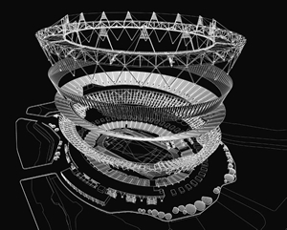

Exploded view of the Stadium’s layers (in its Olympic format)

The stadium design received a mixed response from the media, with reviews ranging from "magnificent" to a "bowl of blancmange"The design was promoted as example of "sustainable development", but some architecture critics have questioned both its aesthetic value and suitability as a national icon – especially when compared to Beijing National Stadium. For example, Ellis Woodman, Building Design's architecture critic, said of the design: "The principle of it being dismountable is most welcome... it demonstrates an obvious interest in establishing an economy of means and as such is the antithesis of the 2008 Olympic stadium in Beijing. But while that's an achievement, it's not an architectural achievement. In design terms what we're looking at is pretty underwhelming." He went on to criticise the procurement and design processes – stating of the latter that it should have been subject to an architectural competition. This view was echoed by Tom Dyckhoff, The Times's architecture critic, who described the design as "tragically underwhelming" and commented that the "architecture of the 2008 and 2012 Olympics will, in years to come, be seen by historians as a "cunning indicator of the decline of the West and the rise of the East".^{[40]} Despite the criticism the Olympic Stadium was nominated for the 2012 Stirling Prize in architecture losing out to the Sainsbury Laboratory at the University of Cambridge
Amanda Baillieu writing in Building Design challenged the designer's claims that the stadium is environmentally sustainable and good value for money. Instead, it is asserted that the reality will be the opposite. In particular, she claimed that:
- the temporary roof could not be reused to cover the permanent 25,000 seating area – given the difference in size;
- it is unlikely that the removed seating would be wanted for any other event e.g. the Glasgow Commonwealth Games; and
- the costs involved in dismantling the stadium – and surrounding "pods" – has not been factored into the estimated cost.
- The cost of £537 million compared to cost of 1908 Olympic Stadium £60,000 (£5.6 million in 2010).

Following the granting, in March 2013, of a 99-year tenancy to West Ham United, the E20 LLP, a joint organisation by the London Legacy Development Corporation and Newham Council were specifically set-up to oversee redevelopment of the stadium into a UEFA Category 4 venue seating 60,000 spectators. The reconfiguration saw work on a new roof, corporate areas, toilets, concessions and retractable seating. West Ham contributed £15 million and Newham Council £40 million for the work to be carried out with the LLDC and the British Government making up the rest. Approval was granted for the installation of retractable seating on all sides of the stadium and an 84-metre (92 yd) transparent roof.

From Football Ground Guide.
“Built for the 2012 Olympics, the London Stadium cost in the region of £500m to build. Originally it had a capacity of 80,000, but this has since been reduced to an all seated capacity of 66,000, although licencing regulations currently restrict the Club to a maximum matchday attendance of 57,000. Since 2012 a further £200m has been spent on further upgrading the facilities, including the construction of the largest cantilevered roof in the World. The build quality of the stadium is excellent and it is certainly up there as being one of the best in the country. The stadium is essentially a bowl design, but when you consider that the stadium was primarily built for athletics and it still retains its ability to host large athletic events, then this is understandable.
“The bowl-like design is quite evident when viewing the stadium from the outside and it to be honest when looked upon during the day its visual impact is somewhat underwhelming. The Club have tried to brighten up its appearance with a 'wrap around skin' featuring various images, including the largest digital screens in Europe and at night when it is lit up, the stadium looks far more impressive. Inside, the stadium is bright and 'airy'. Certainly, the 14 large triangular towers fitted into the front of the mostly translucent roof, certainly create this feeling and are a unique feature in themselves. The stadium is totally enclosed with all sides being essentially two tiered, although the West Side gives the illusion of having three tiers, as a large corporate area has been installed at the front of the upper tier of what is now called the Betway Stand. Strangely there is a larger gap between the front of this stand and the playing area, compared to the opposite East Side. You just would have thought that the 'posher' seats would be located in the closer stand. Interestingly, parts of the lower tier is made up of large blocks of retractable seating that can be moved backwards and forwards to make way for an athletics track, or for other events taking place at the stadium when needed. For football matches these blocks are pushed forward to cover parts of the area of the athletics track. But in doing so there are quite large gaps present between the back of the pushed forward blocks and the rest of the stand. So much so, that elevated walkways are put in place to allow access from the concourse behind. At each end there is a large digital screen located between the two tiers.”
Here is an image of the Boleyn Ground inside the Emirates stadium inside the London stadium

