Points on Cabinet Document: “Sustainable Transport and Highways – Covid 19 Response”
Newham Cyclists very much welcome and agree the analysis of need to promote active travel in Newham particularly in the light of the current Covid – 19 crisis.
The rightly paper recognises the need to rebalance the priority away from motor vehicles and towards active travel.
We welcome that Newham Council are actively pursuing other external funding opportunities in the face of TfL cuts in existing funding affecting active travel.
We welcome the use of Experimental Traffic Orders to implement schemes as suggested in Government Statutory guidelines.
Although it has taken over a month from the publication of the Government’s statutory guidelines to this Cabinet meeting, we agree the urgency demands that the Cabinet should delegate to the Corporate Director of Environment and Sustainable Transport in consultation with the Mayor and the Cabinet Member for Environment and Sustainable Transport the implementation of the Newham response.
We appreciate that existing TfL funding to the tune of £5m has been cut and replaced with the uncertainty of re-allocation and the need to bid anew. Nor do we underestimate the workload that this involves.
However the proposals revealed by the Cabinet papers demonstrate a continued lack ambition, failure to match urgency to the circumstances, and an apparent reluctance to embrace all of the (non-exhaustive) list of possible measures in the Government’s statutory guidelines which local authorities were exhorted, on 9 May, to implement within weeks. The need for urgency was recently reinforced by the bidding conditions for the first DFT Emergency Funding for London which required submitted schemes to be in place in 8 weeks.
We fear that the lack of urgency will jeopardise the success in bidding for emergency funding that is needed if Newham is not to fall further behind in active travel.

Section 1: Lack of urgency
1 Para 3.24: “Officers are well-advanced in identifying schemes in all three of these categories, so we are hopeful for a good allocation from this programme” (underlining ours) i.e. there are schemes still to be identified, let alone worked up.
2 The immediate rebalancing by using the heavily criticised Keep Newham Moving Funding (a £100m facility essentially to be spent on resurfacing) for active travel is limited - to (a) the immediate schemes in Appendix A (24 pavement widening, 25 pavement decluttering, an unstated number of parking bay suspensions in 25 locations, 1 low traffic neighbourhood and 7 school streets – unless the school objects ) (b) key complementary activities that the LiP funding would have been used for and (c) only in the current financial year. Any more fundamental rebalancing is left to a later review. This call on this facility is not likely to match the notional £10m per year available from this money, especially if other sources of funding become available for these purposes.
- Only 2 cycle corridors for Romford Rd and North Woolwich Rd of which the latter is only a small section of the strategic corridor - and then only to be explored if funding is available.
There are a number of “strategic cycle corridors” identified by Tfl in 2016 i.e. areas of high potential cycle usage. One is Romford Rd; and North Woolwich Rd forms part of the strategic corridor from Manor Park to North Woolwich. Barking Rd is a strategic cycle corridor and should be included.
Plans are very vague – no reference to 24 hour bus lanes or rephrasing of lights.
- Only one Low Traffic Neighbourhood in the immediate future.
But at least two more could and should have been brought forward urgently.
- Custom House Low traffic Neighbourhood was in planning stage development and had secured first stage TfL funding.
- Low Traffic Neighbourhood 4 only requires 2 modal filters (which could be a simple as planters) to have effect. This should be for early action.
Paras 4.15 – 4.18 of the document imply that Keep Newham Moving funding could be used for Low Traffic Neighbourhoods other than the one listed in Appendx A for immediate implementation. But a careful reading of 4.18 shows that this is not the case (although it should be).
Section 2: Omissions
- No reference at all to 20 mph speed limits
Reducing speed limits: 20mph speed limits are being more widely adopted as an appropriate speed limit for residential roads, and many through streets in built-up areas. 20mph limits alone will not be sufficient to meet the needs of active travel, but in association with other measures, reducing the speed limit can provide a more attractive and safer environment for walking and cycling.
Borough wide 20 mph, long resisted by Newham Council, would be a clear cheap early win.
- No reference to improving enforcement action in favour of walking and cycling.
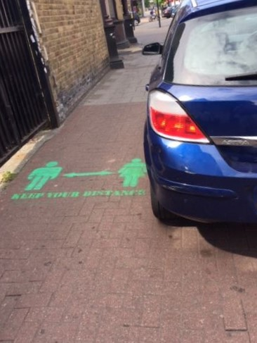

- No reference to reversing many instances where Council has made parking on the pavement legal - even in Odessa Rd where there were existing plans to do this.
This is vital for social distancing. It may require a traffic order but delegated authority is being sought for a number of experimental traffic orders.
The paper focusses on pavement widening only in town centres. But walking will be a key mode of transport for local journeys to school, to parks and to workplaces.
- No reference to implementing smaller schemes (drop kerbs, signing and similar) whose previous neglect has hitherto contributed to Newham’s poor facilities for active travel.
There should have been a commitment to respond to suggestions from the public on the (yet unopened) portal that should be open this week.
Newham Cyclists have proposed a number of such minor improvements which over a short time could significantly contribute to a pleasanter environment for active travel.
- No question of ensuring the quality of measures which purport to help active travel.
Newham Council has a record of schemes that are ill thought out and poorly implemented from the perspective of active travel. This is liable to continue. Indeed one of the photo example in appendix E of Woodgrange Rd is of temporary pavement widening which falls short of the distance required and has thus created a space which lack of enforcement of parking restrictions means has become an ad hoc parking space.
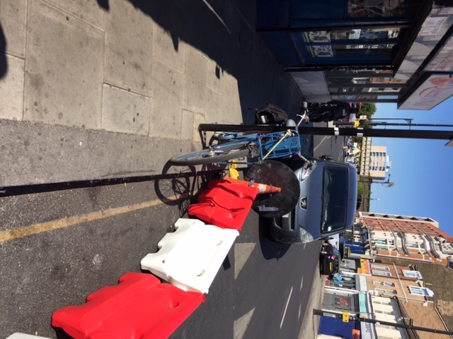
- No reference to increase cycle parking
There is a danger than decluttering exercises will reduce cycle parking.

Section 3: Other Lack of Ambition

- Only 1 and a bit corridors “to be explored” if funding becomes available – see item x above.
- Only 7 School Street proposals and then only if school agrees
There are approximately 100 schools in Newham.
13 Only one Low Traffic Neighbourhood
See above
- There is no reference to the number of parking bays suspended or to be suspended in appendix A.
First impression are that these are limited.

Newham Cyclists
5 June 2020

Executive summary and section 3.
Paras 2.2.5 and 2.26.
Para 3.3.6.
See para 1.11 – 1.12
Paras 3.40 and 3.41 and 4.21 indicate the limited exposure of the Keep Newham Moving Fund to reallocation even when its current purpose is blocked.
Para 4.11
Gov Guidance: “Installing ‘pop-up’ cycle facilities with a minimum level of physical separation from volume traffic; for example, mandatory cycle lanes, using light segregation features such as flexible plastic wands; or quickly converting traffic lanes into temporary cycle lanes (suspending parking bays where necessary); widening existing cycle lanes to enable cyclists to maintain distancing. Facilities should be segregated as far as possible, i.e. with physical measures separating cyclists and other traffic. Lanes indicated by road markings only are very unlikely to be sufficient to deliver the level of change needed, especially in the longer term.” And “Whole-route’ approaches to create corridors for buses, cycles and access only on key routes into town and city centres.”
Gov guidelines: “Modal filters (also known as filtered permeability); closing roads to motor traffic, for example by using planters or large barriers. Often used in residential areas, this can create neighbourhoods that are low-traffic or traffic free, creating a more pleasant environment that encourages people to walk and cycle, and improving safety.”
Gov guidelines “Identifying and bringing forward permanent schemes already planned, for example under Local Cycling and Walking Infrastructure Plans, and that can be constructed relatively quickly.”
Gov Guidance “Providing additional cycle parking facilities at key locations, such as outside stations and in high streets, to accommodate an increase in cycling, for example by repurposing parking bays to accommodate cycle racks.”
Gov guidelines “Encouraging walking and cycling to school, for example through the introduction of more ‘school streets’. Pioneered in London, these are areas around schools where motor traffic is restricted at pick-up and drop-off times, during term-time. They can be effective in encouraging more walking and cycling, particularly where good facilities exist on routes to the school and where the parents, children and school are involved as part of the scheme development.”

