NEWHAM CYCLIST AUDIT OF ROMFORD ROAD 19 JUNE 2020

Principles to be applied:
- Cycle lanes to be mandatory and 24 hrs with no parking. Advisory cycle lane only if absolutely necessary and then 24 hour with no parking. All cycle lanes to be at least 1.5 m wide and segregated by wands, armadillos or other form of temporary separation.
- Cycle lanes to continue across junctions with minor roads and start immediately after junctions with major roads
- Bus lanes to be 24 hours with no parking in them.
- 20mph limit.
- Parking spaces removed and Inset parking to be removed or converted to limited time loading.
- Enforcement.
- Pinch points and islands to be removed. Refuges replaced where necessary with single stage zebra crossing.
- Advance Stop Lanes to be big enough and with mandatory cycle lane access.
- To encourage walking, side roads as Copenhagen pavements; or (temporarily) paint give way line behind line of pavement.
- Tidy signage.
- Fill holes in road surface on cycle lanes.
- Phasing of pedestrian crossings to prioritise pedestrians rather than motor traffic.

ILFORD TO STRATFORD
From A 406 to Roding Way crossing
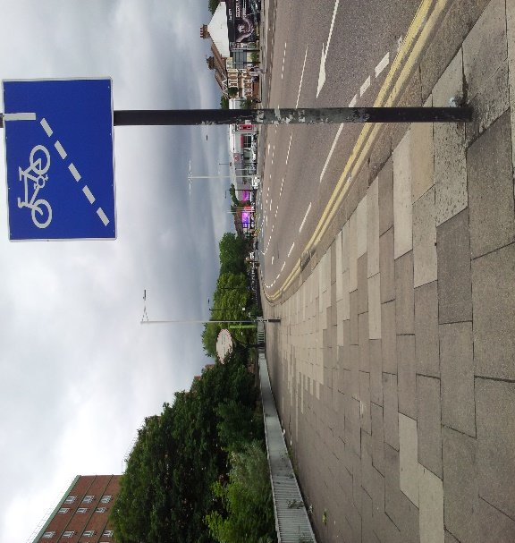
Romford Rd Westbound (adjacent to Enterprise Car Rental premises).
- Mandatory cycle lane.
- Limit right turn lane to area of hatchings as right turn to Lugg Approach is little used. Less satisfactory alternative is shared use pavement.

Roding Way Crossing to Little Ilford Lane
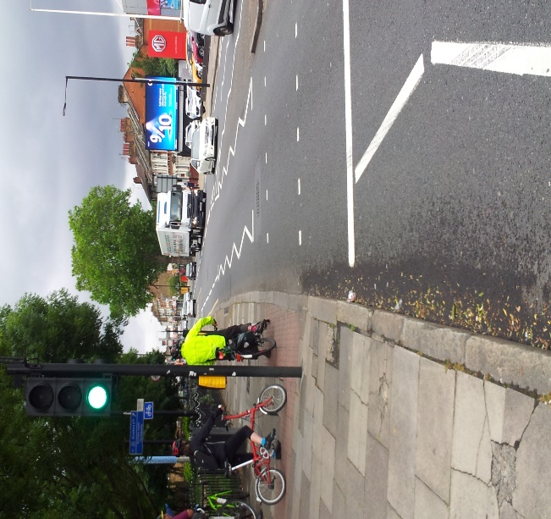
Romford Road Westbond (Approach to Roding way Crossing). Grantham Rd
- Single step crossings at Roding Way and remove hatchings to create space for mandatory cycle lane.
- Remove parking bays
- Single step crossing at approch to Sheringham Ave.
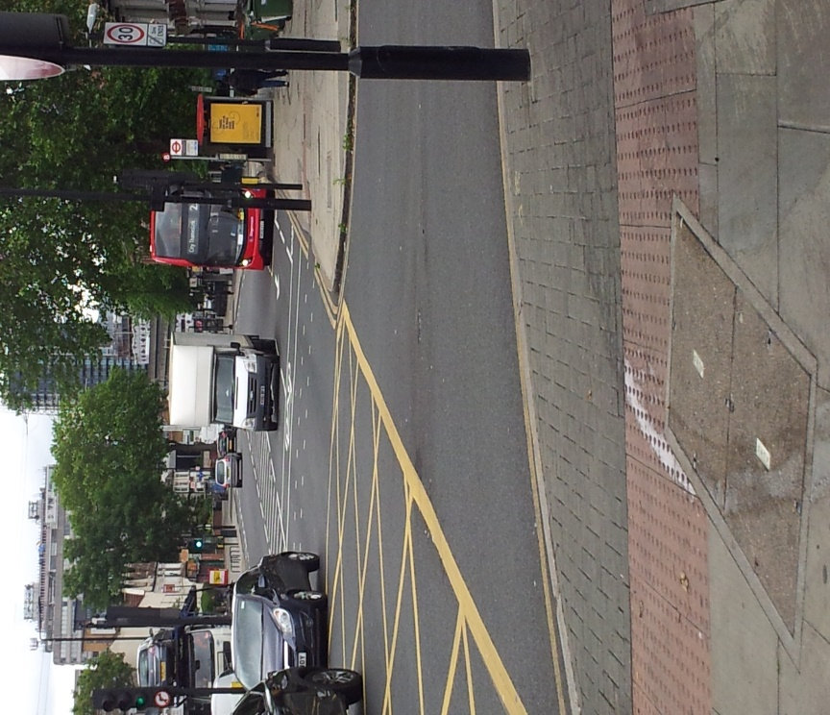
Romford Rd Westbound – looking back at junction with Little Ilford Lane.
- Mandatory cycle lane to increased ASL.
Little Ilford Lane to Rabbits Rd

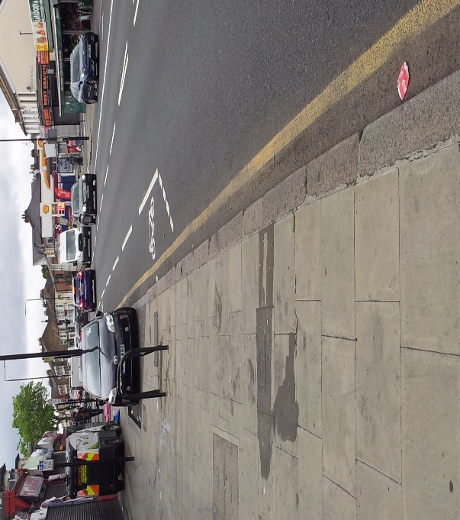
Romford Road Westbound- off set parkign bays on approach to Eighth Avenue
- Mandatory cycle lane starting at junction (or shared use pavement to fill in gap to cycle lane)
- Remove parking bays or reduce to limited time loading.
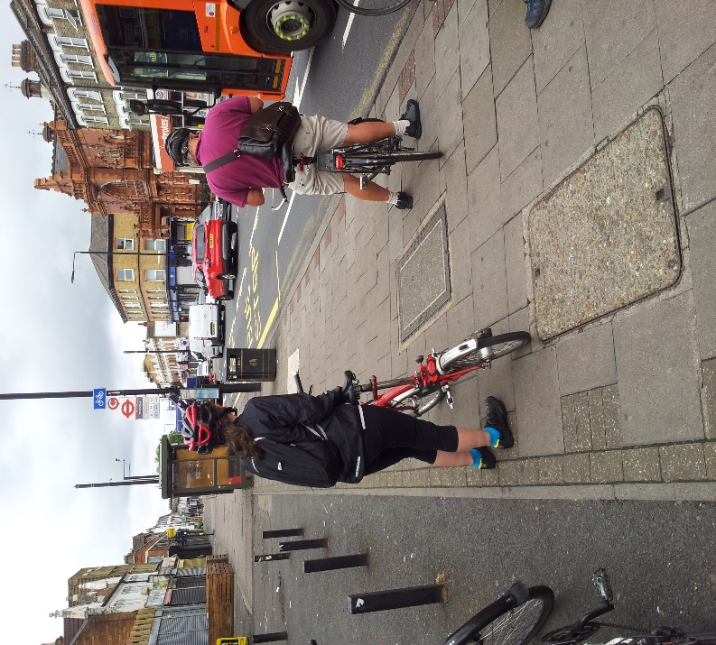
Romford Rd Westbound – bus stop on approach to Fourth Ave
- From Fifth Ave use some of wide pavement for cycle lane/shared use if right turn into Rabbits Rd is preserved.
Rabbits Rd to High St North

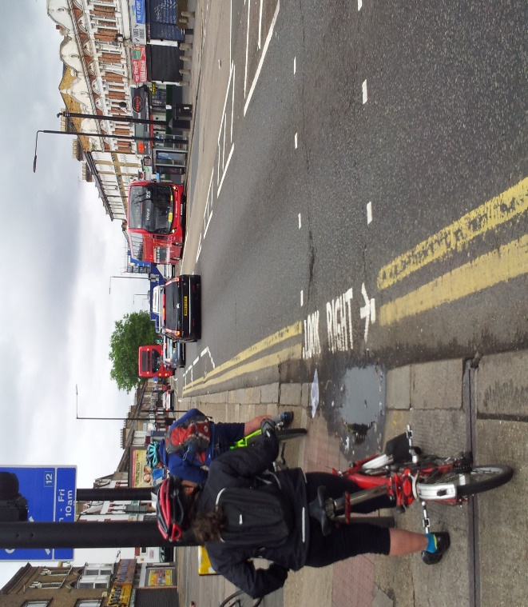
Romford Rd Westbound – approach to Third Avenue
- Mandatory cycle lane to start at junction of Fourth Ave
- Remove parking bays or convert to limited time loading.
- One lane at junction with High St North for forward and left turn as no right turn.

High Street North to Shrewsbury Rd
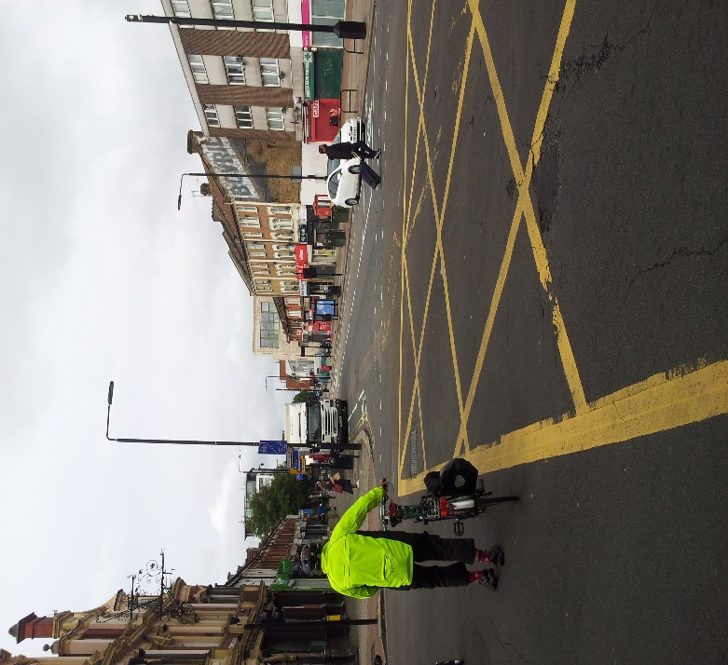
Romford Rd Westbound –at High St North junction

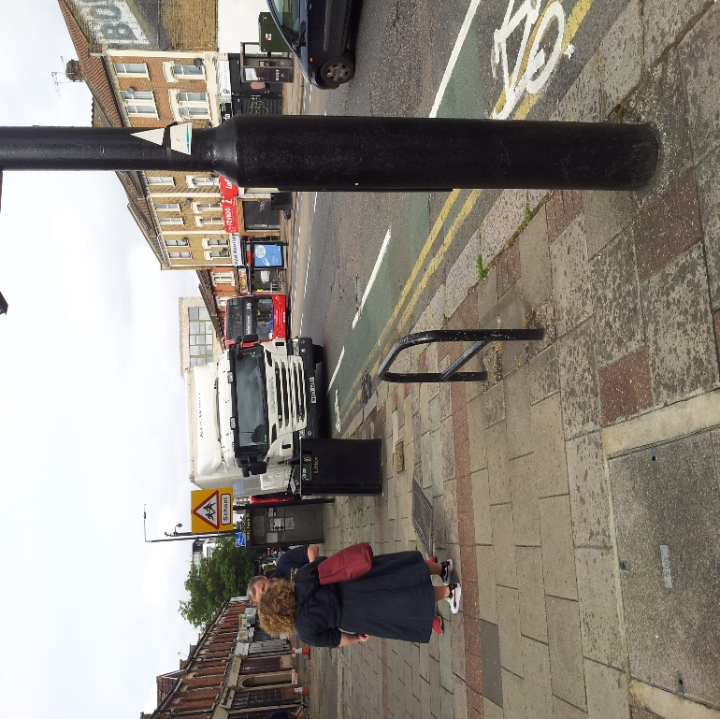
Romford Rd Westbound-just past junction with High St North
- Mandatory cycle lane from High St North
- Remove parking bays or convert to limited time loading.
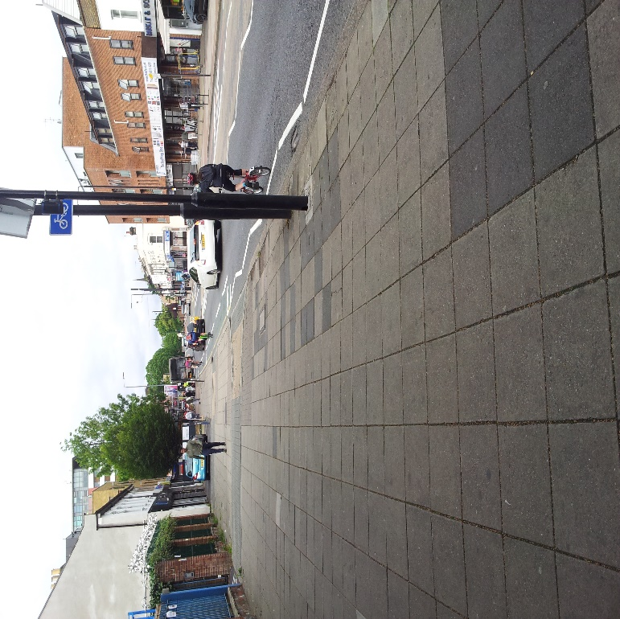
Romford Rd Westbound- adjacent to Salisbury Rd Primary School
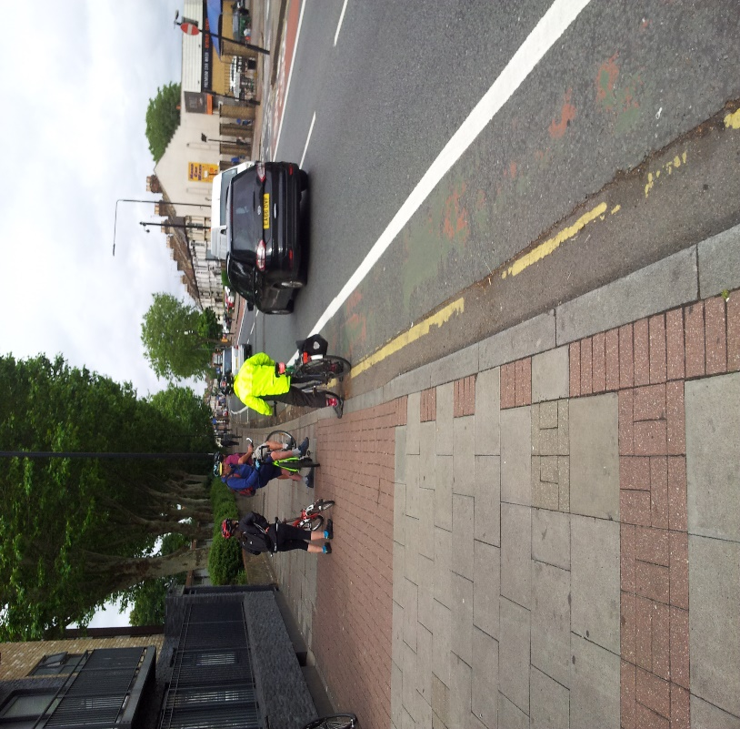
Romford Rd Westbound – opposite Hampton Rd junction.
- Remove refuge or convert to zebra near Salisbury School.
- Single step crossing at Shrewsbury Rd.

Shrewsbury Rd to Green Street
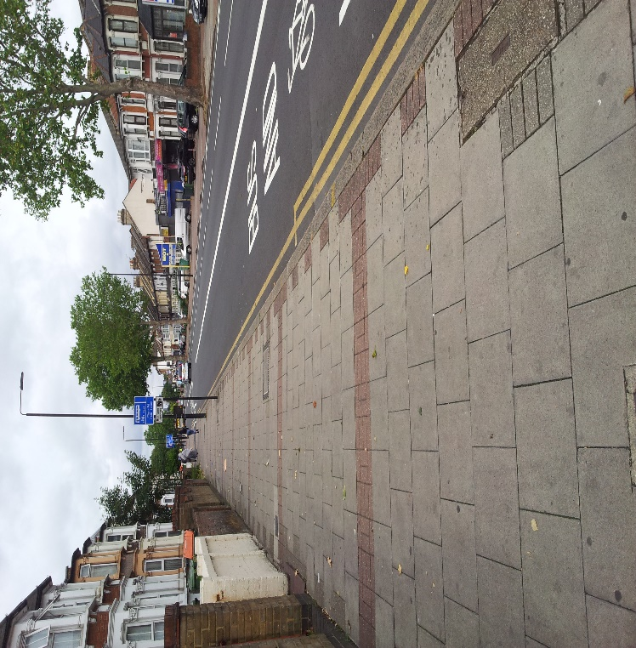
Romford Rd Westbound – between Nigel Rd and Birchdale Rd
- Bus lane 24 hr from Shrewsbury Rd
- Remove parking bay Quaker Place to Nigel Rd.

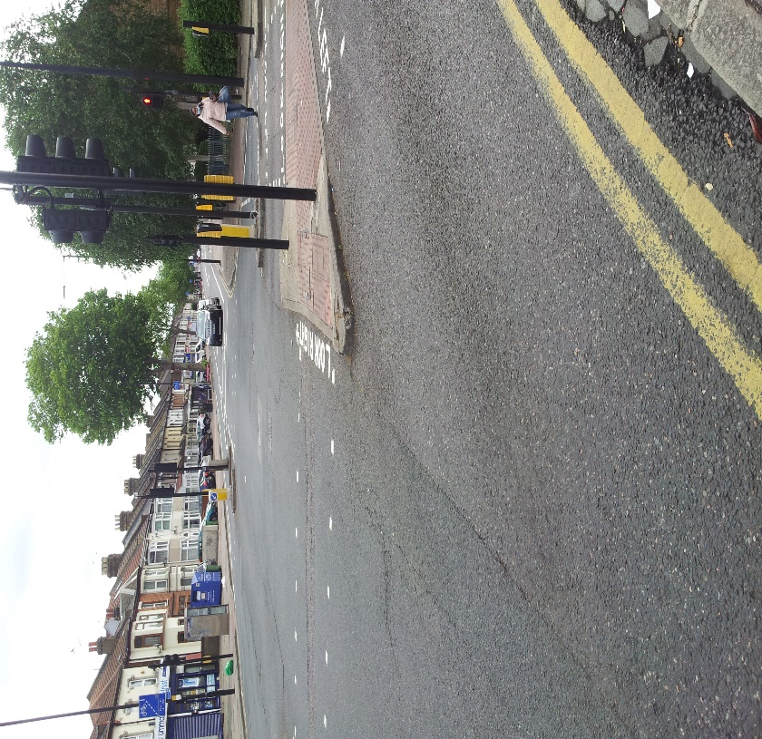
Romford Rd Westbound – Looking back at Katherine Rd junction.
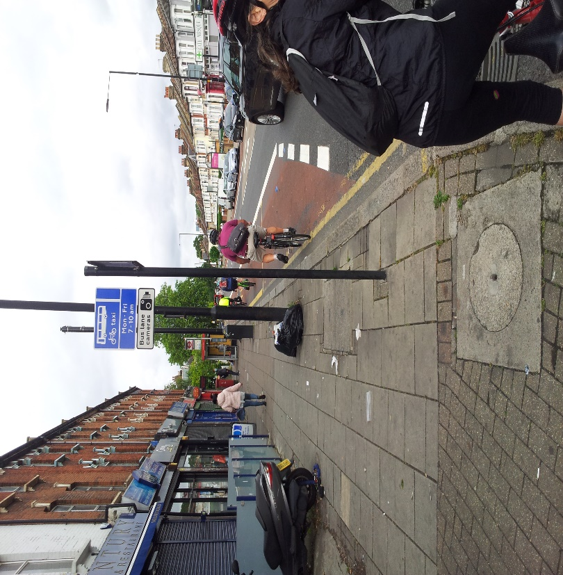
Romford Rd Westbound – just past Katherine Rd.
- 24 hour bus lane from Katherine Rd
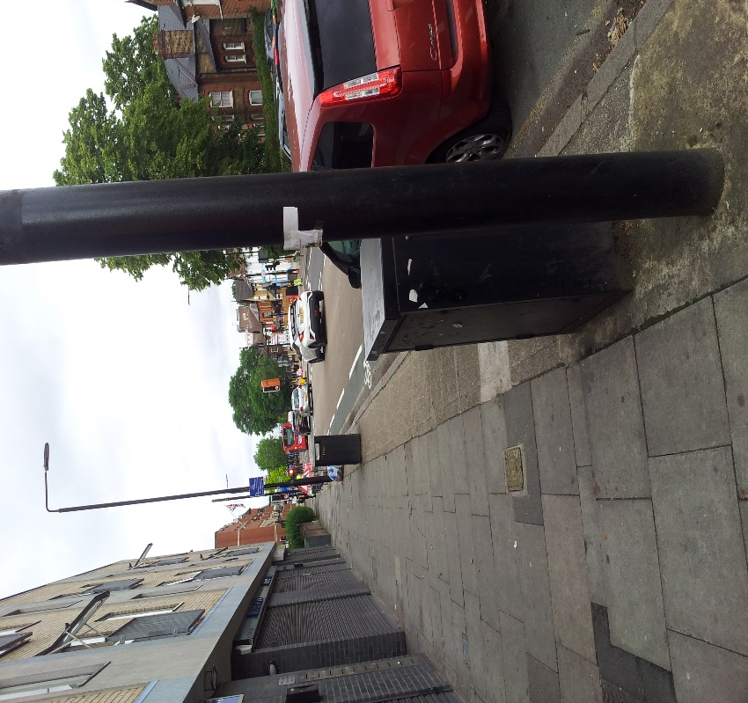
Romford Rd Westbound – between Radcliffe Rd and Green St.
- Remove parking places and remove parking bays or convert to limited time loading.
- Single lane of traffic at approach to Green Street as little traffic turns right into Richmond Rd. and make mandatory cycle lane to ASL.

Green St to Upton Lane
- 24 hour bus lane from junction.
- Single step crossing at approach to Upton Lane and single motor traffic lane for forward and left to create space for mandatory cycle lane at end of bus lane leading to an increased ASL.
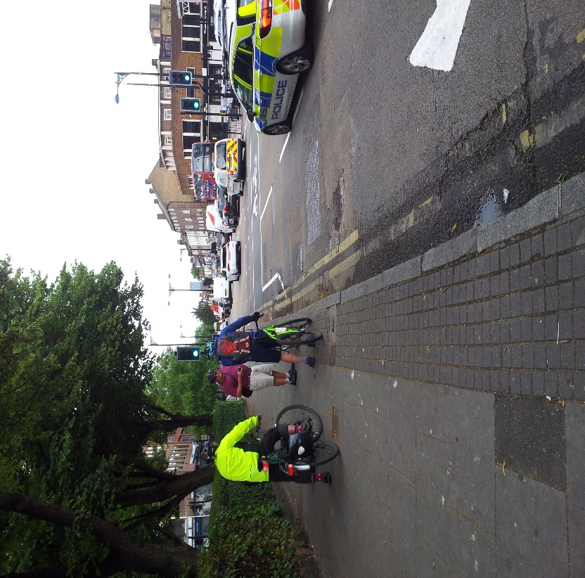
Romford Rd Westbound –Approach to Upton Lane
- Remove “sheep pen” on both sides of junction and have single step crossing like High St North, making space for mandatory cycle lane to ASL.
Upton Lane to Vicarage Lane
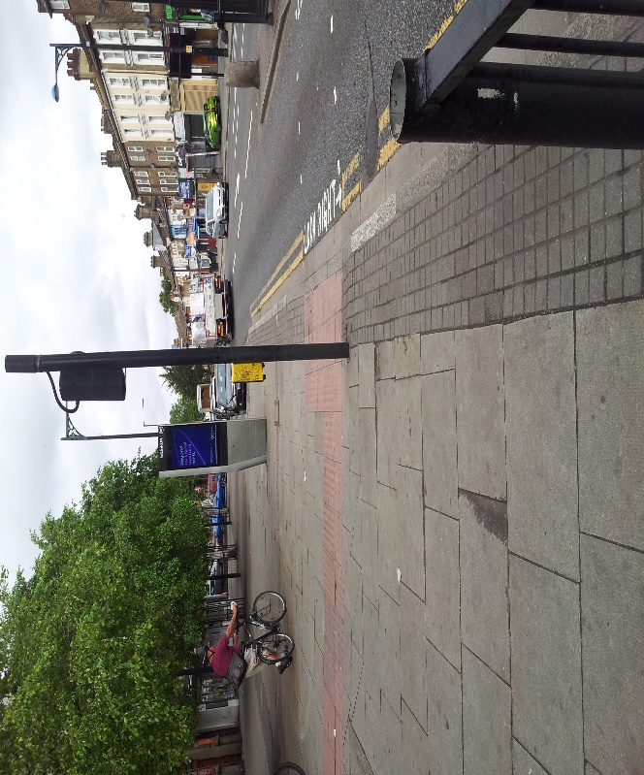
Romford Rd Westbound – just past Upton Lane
- Remove “sheep pen” on both sides of junction and have single step crossing like High St North on west side of junction to make space for mandatory cycle lane (where there is no cycle lane) or remove build out or put cycle lane on edge of wide pavement.
- Remove parking bays or convert to limited time loading.
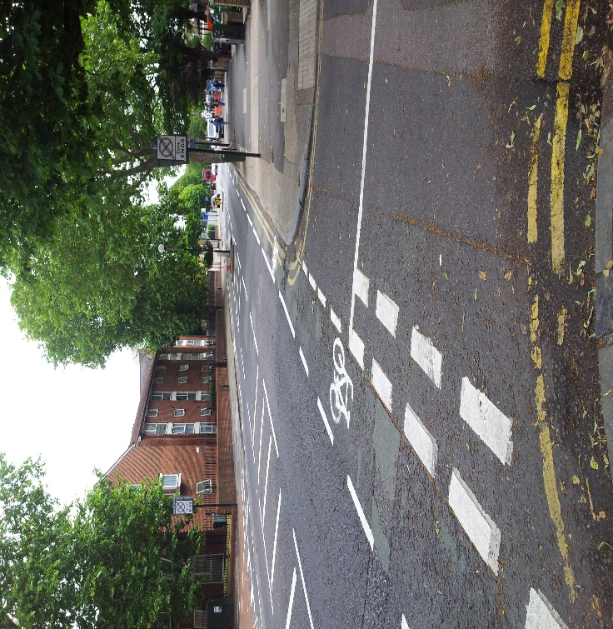
Romford Rd Westbound – Looking back at Warwick Rd junction.
- Make cycle lane mandatory and continuous, removing pinch points just after Disreali Rd, and just before Cosby Rd and just after Faraday Rd and just before Warwick Rd – possibly converting some of these into a single step zebra crossing.
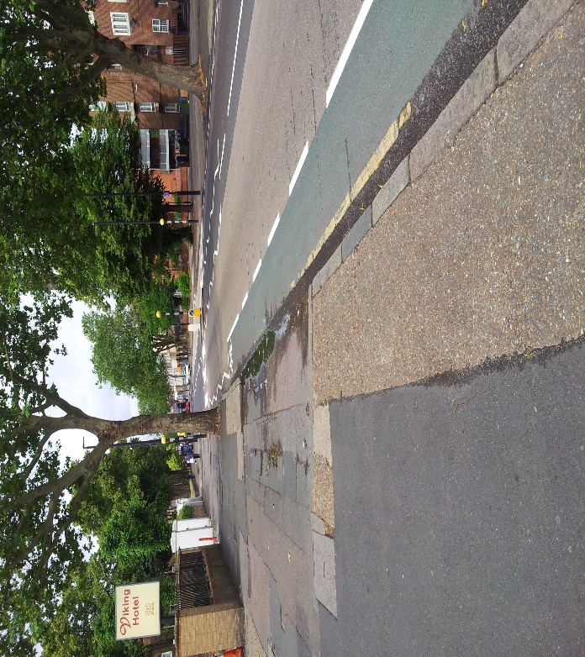
Romford Rd Westbound – Approaching Dyson Rd
- Single step Zebra crossing at approach to Dyson Rd
- Remove pinch point just after Tavisock Rd
- Cycle lane approach to ASL at Vicarage Lane.
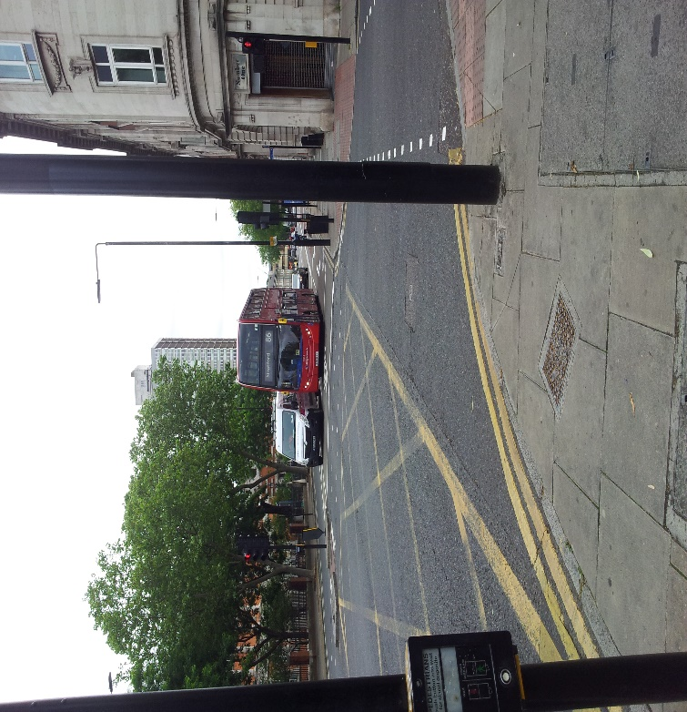
Romford Rd Westbound – Looking back at Vicarage Lane junction
- At approach to Vicarage Lane bus lane to be 24 hour.
- Remove taxi rank outside court building.
- Make single lane forward and left (there is no right turn into Water Lane) to continue bus lane or insert mandatory cycle lane to access increased ASL.
Vicarage Lane to The Grove
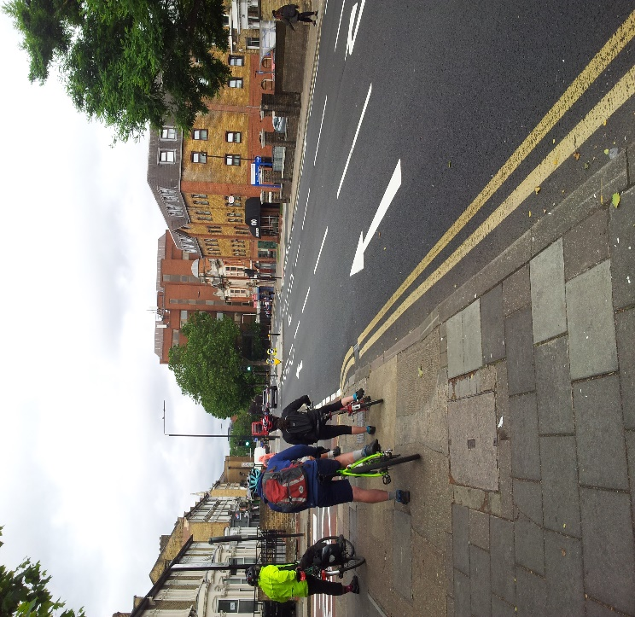
Romford Rd Westbound – Approach to Glenavon Rd junction.
- Bus lane from Vicarage Lane 24 hour.
- Remove right hand turn lane into Deanery Rd to insert mandatory cycle lane or extend 24 hour bus lane. Possibly reverse direction of one way in Deanery Rd.
- Remove island to allow continuous bus lane or mandatory cycle lane.
- Shorten right hand turn lane and insert mandatory cycle lane from Mantle Way to start of Stratford Town Centre scheme. This allow more space for mandatory cycle lane outside Solar House.

STRATFORD TO ILFORD
Stratford to Water Lane

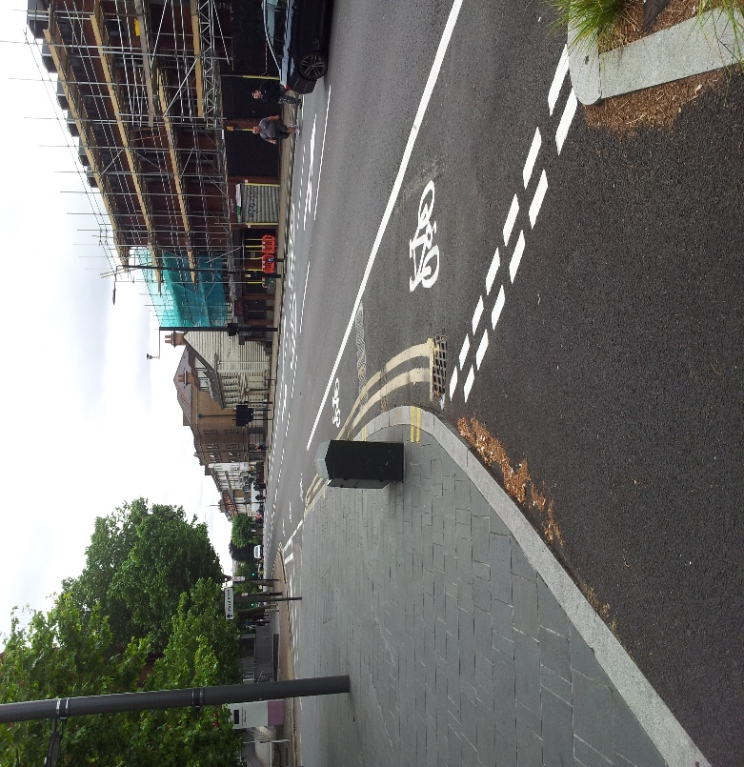
Romford Rd Eastbound – just past Grove junction
- Mandatory cycle lane outside Solar house (using space created by shortening right hand turn westbound.
- Remove right turn lane into Tennyson Rd (to be part of a a low traffic neighbourhood) to continue mandatory cycle lane to Deanery Rd (where island will be removed.)
- Mandatory cycle lane from Deanery Rd to Water Lane up to ASL.

Water Lane to Woodgrange Rd
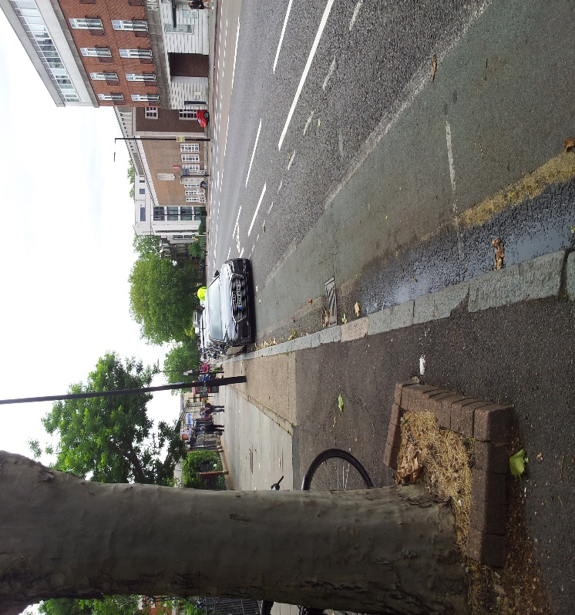
Romford Rd Eastbound – just past junction with Water Lane.
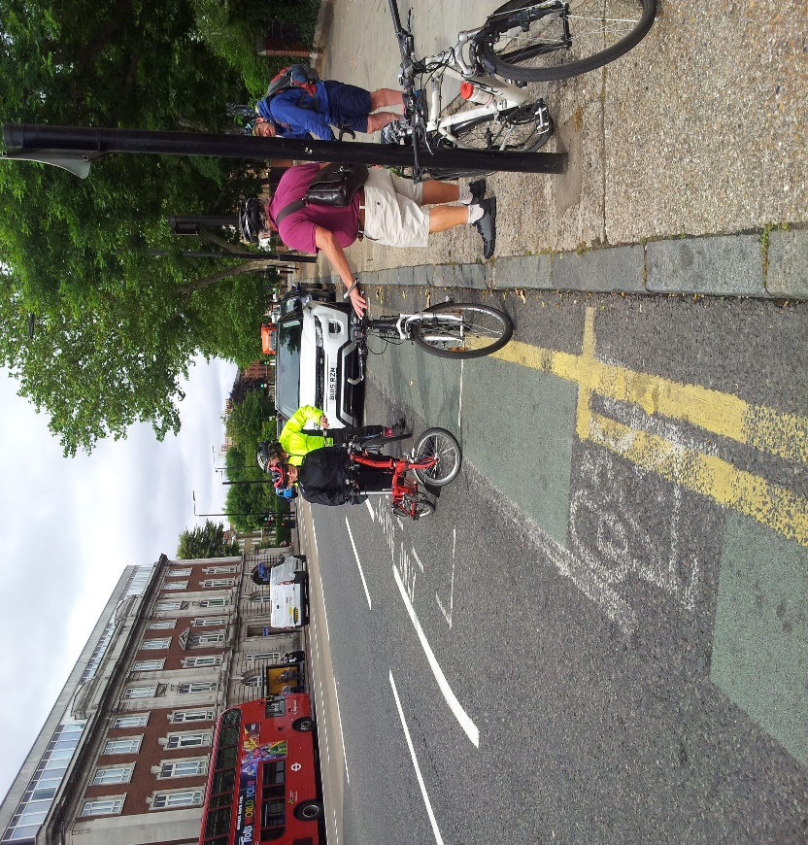
Romford Rd Eastbound – Looking back to Water lane junction from outside UEL.
- Remove parking outside of UEL building or convert to inset limited time loading bays.
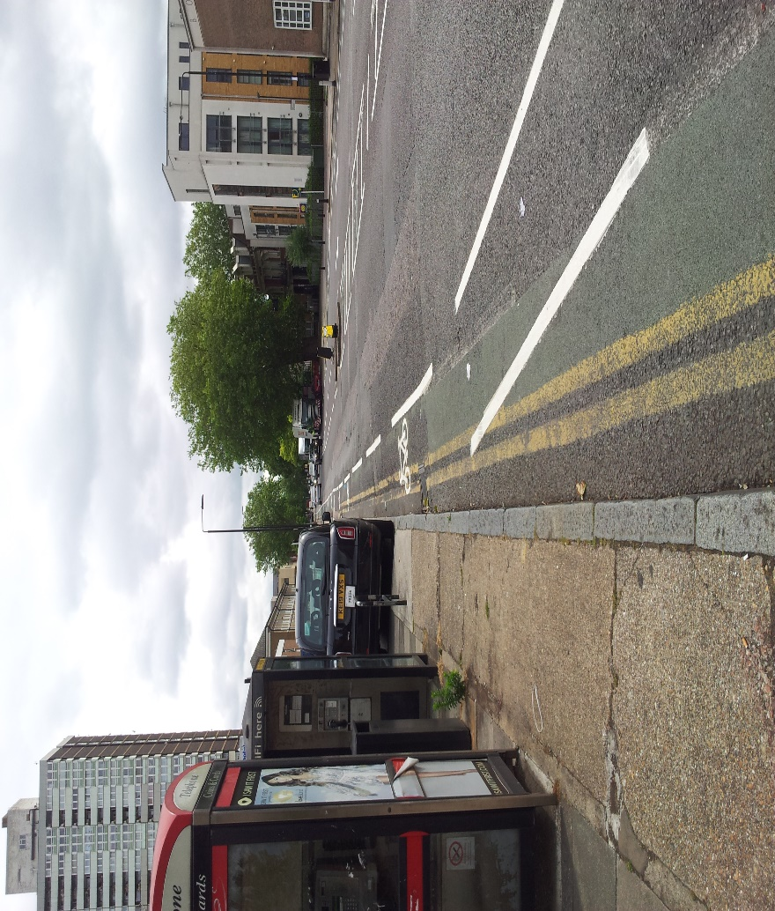
Romford Rd Eastbound – opposite bow county court building.
- Mandatory cycle lane from Water Lane to Radlett Close, removing pinch points just before Ferns Rd, and Faraday Rd, making zebra just after Hamfrith Rd single step.
- Remove right turn lane into Warwick Rd
- Remove pinch point after Atherton Rd.
- Consider making pinch points single step zebra crossings.
- 24 hour bus lane from Radlett Close to Woodgrange Rd.

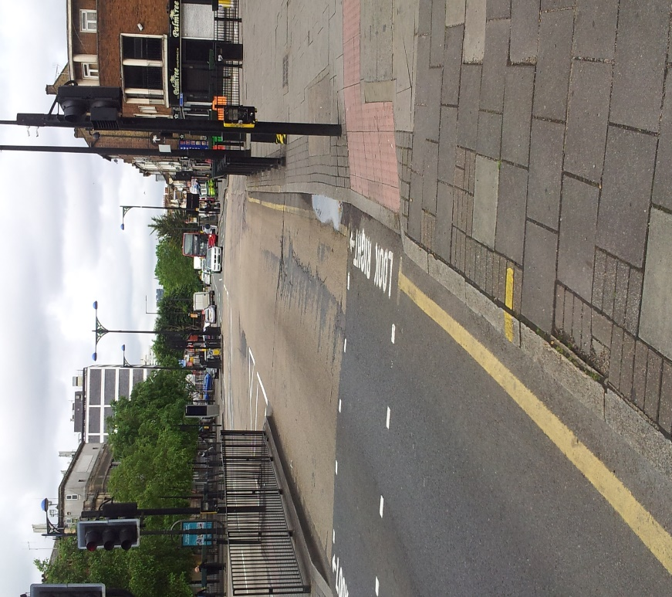
Romford Rd Eastbound – Looking back at junction with Woodgrange Rd.
- Approaching Woodgrange Rd remove “sheep pen” on both sides of junction and have single step crossing like High St North. Also single motor traffic lane for forward and left to make space for mandatory cycle lane to increased ASL at junction. Remove parking bays or convert to limited time loading.
Woodgrange Rd to Richmond Rd

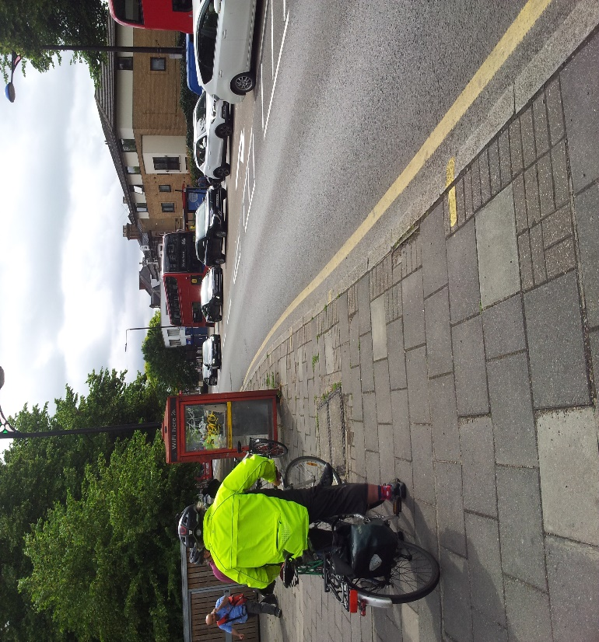
Romford Rd Eastbound – just past Woodgrange Rd junction.
- Remove “sheep pen” on both sides of junction and single step have crossing like High St North
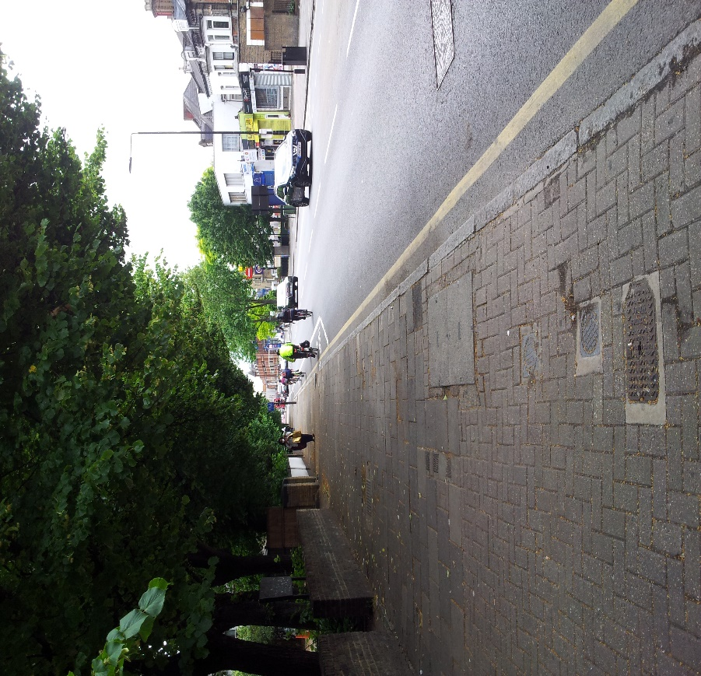
Romford Rd Eastbound – further past Woodgrange Rd junction.
- Continuous mandatory cycle lane from Woodgrange Rd to Richmond Road.

Green Street to Balmoral Rd

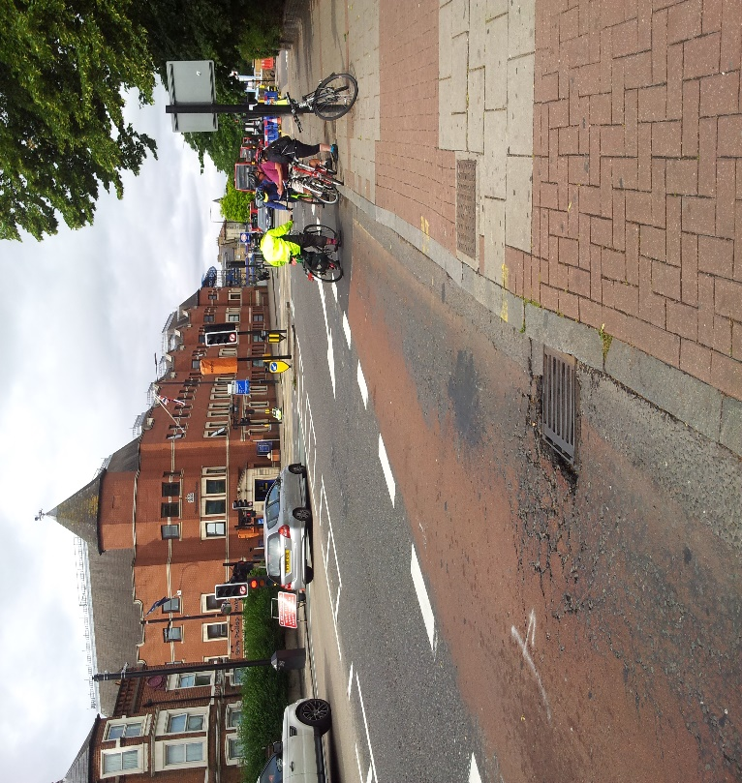
Romford Rd Eastbound – Looking back at Richmond Rd junction.
- 24 hour bus lane to approach of Balmoral Rd.

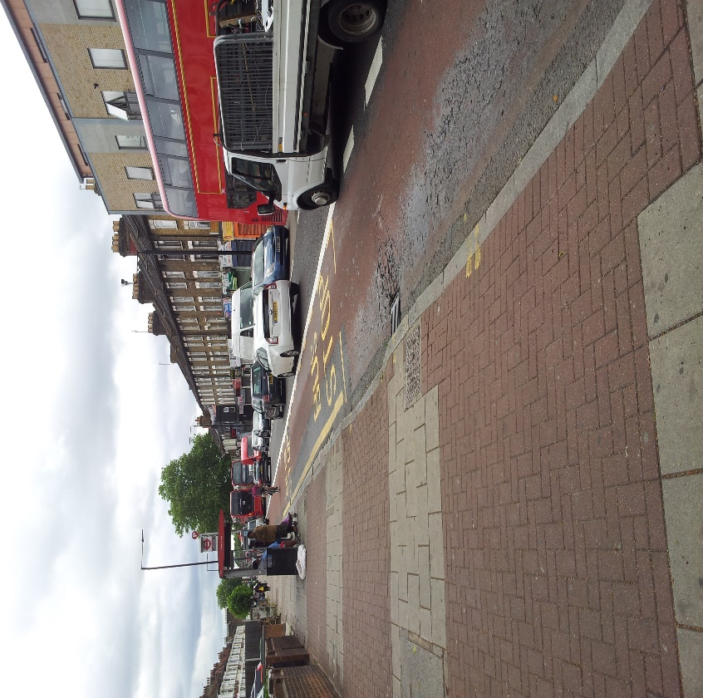
Romford Rd Eastbound – just past junction with Richmond Rd.
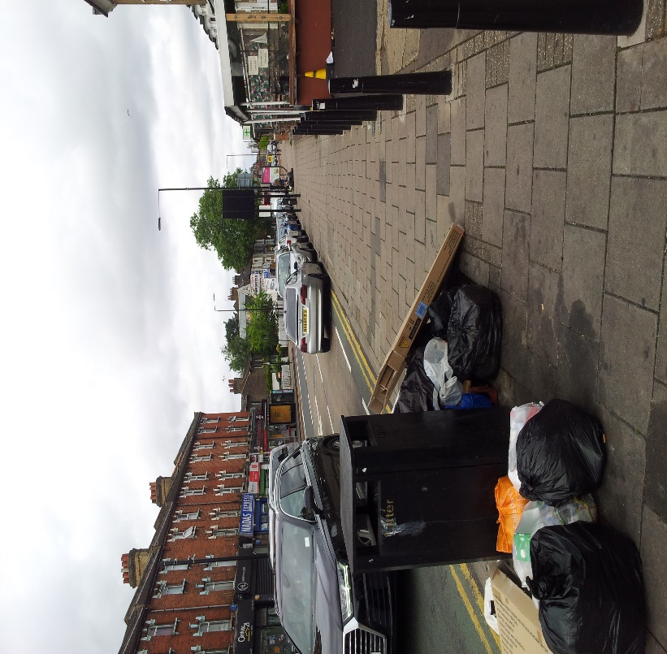
Romford Rd Eastbound – Looking back at the approach to junction with Balmoral Rd.
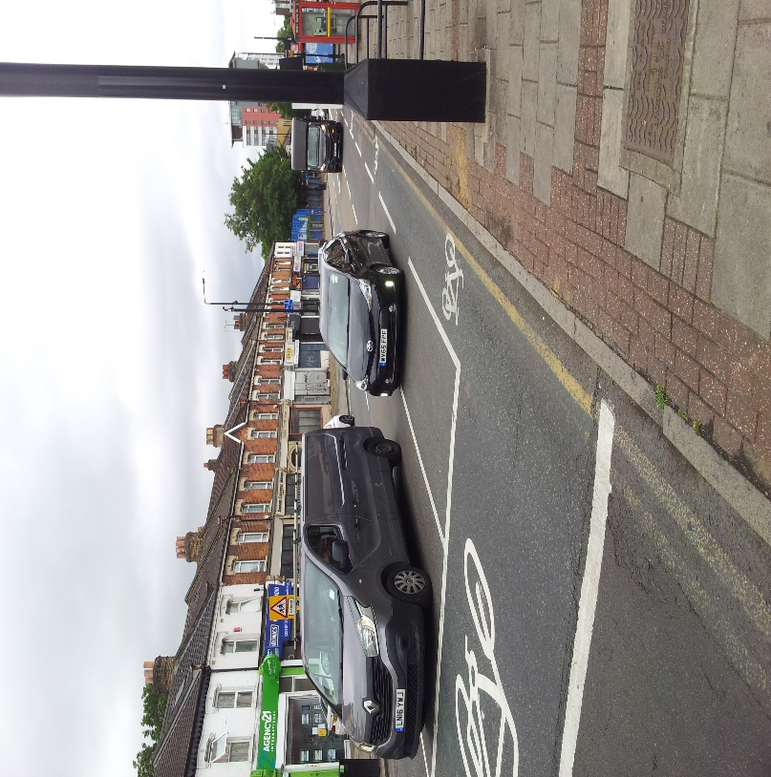
Romford Rd Eastbound – Looking back at the approach to junction with Balmoral Rd.
- Remove parking
- Mandatory cycle lane on approach to ASL at Balmoral Rd.
- Remove parking spaces outside Claremont Clinic.
Balmoral Rd to Station Rd
- Keep mandatory cycle lane to opposite Shrewsbury Rd
- Crossing at Shrewsbury Rd to be made single step.
- Bus lane to Shrewsbury Rd to Station Rd to be 24 hour.
- Remove pinch point approaching Salisbury School.
- Approaching Station Rd reduce to one lane for forward and left traffic (there is no right turn into High Street North) to insert mandatory cycle lane to ASL.

Station Road to Rabbits Road.
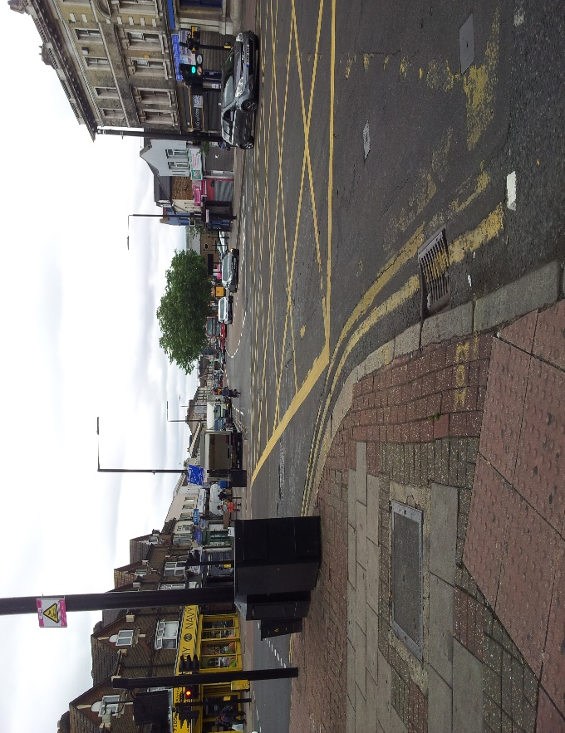
Romford Rd Eastbound – junction with Station Rd.
- Mandatory cycle lane from junction with Station Rd.
- Bays to be limited time loading only.
- 24 hour bus lane to extend to Rabbits Rd or mandatory cycle lane on approach to Rabbits Rd.

Rabbits Rd to Colchester Avenue
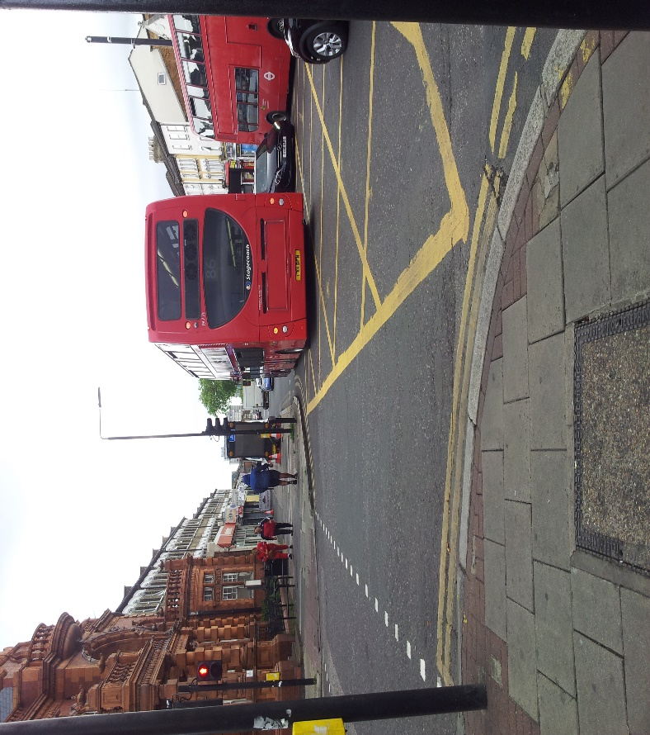
Romford Rd Eastbound – junction with Rabbits Rd.
- Mandatory cycle land from Rabbits Rd to Michigan Ave if necessary by removing some pavement and parking bays. Otherwise convert parking bays into limited time loading.
- Bus lane from Michigan Ave to be 24 hour with parking bays just after Michigan Ave and just before Worcester Rd, just before Gloucester Rd and just before Colchester Ave converted to limited time loading.
Colchester Ave to A 406
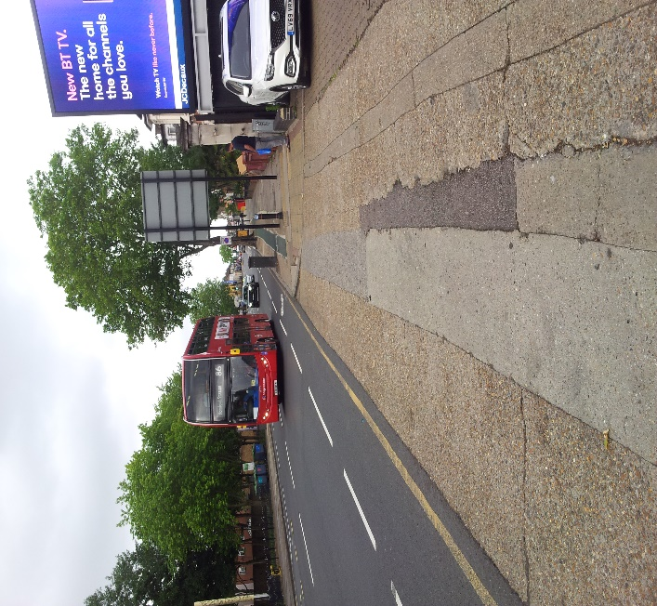
Romford Rd Eastbound – Opposite Grantham Estate.
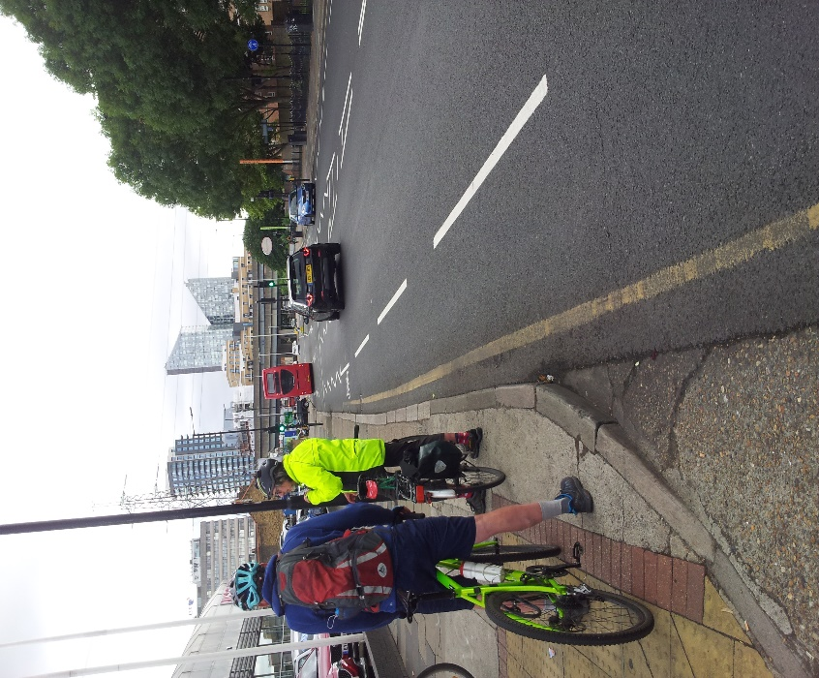
Romford Rd Eastbound – Adjacent to Glyn Hopkin Garage
- From Colchester Ave cycle lane to be made mandatory
- Single stage pedestrian crossing just past Sheringham Rd

Under A 406 and Ilford Hill to be dealt with as part of “Ilford Gardens” project for which Redbridge is funded.

