Westfield Avenue and Surrounding Streets: Consultation
Westfield Ave between International Way and Montfichet Rd
Westfield Avenue is a local road designed as route network route. It should be converted to one lane each way with a 20 mph limit (as in Stratford Town Centre and elsewhere in the QEOP) and the unnecessary central reservation removed. This would create enough space to provide segregated unidirectional cycle tracks on each side of the road with priority over side roads, improved pavement for pedestrians and provide improved public space. The substandard pavement cycle tracks could be removed.
At junction with Montfichet Rd only one right turn lane needed. Remove barriers. Provide toucan crossing with shared use pavements at corners accessed by drop kerbs to allow cyclists to use the crossings for right turn manoeuvres i.e. for cyclists travelling south along Westfield Avenue to turn right into Montfichet Rd and for cyclists travelling westbound on Montfichet Rd to turn right into Westfield Avenue.
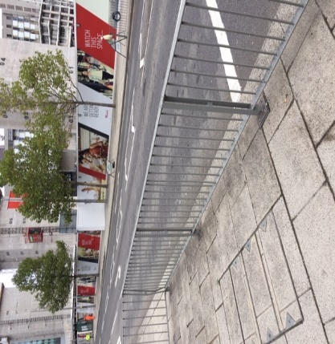
Westfield Ave approaching Montfichet Rd
Westfield Ave Junction with International Way
Re-engineer this junction as a simple T junction with (southbound) one lane forward and one lane turn left. Have single stage toucan crossings and shared use pavements at corners (accessed by drop kerbs) to facilitate cyclists wanting to turn right into International Way from Westfield Avenue and from International Way into Waterden Rd.

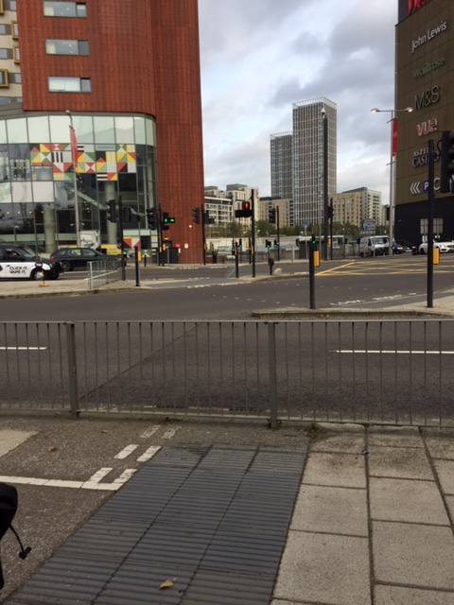
Junction of Westfield Ave and International Way

International Way
Provide cycle access to Roundhouse Lane and make it legal for those cycling to use this road to reach cycle parking near Stratford International Station, which should be increased.
Close International Way over railway bridge between Roundhouse Lane and the bus stand to all but cycles, buses and taxis.
Provide continuous segregated unidirectional cycle tracks each side of International Way from Bus stand to Montfichet Road with provision for those cycling to proceed eastbound along International Way at the junction with Celebration Avenue and a toucan crossing with shared use pavements at corners accessed by drop kerbs to allow cyclists to use the crossings for right turn manoeuvres i.e. for cyclists travelling south along Celebration Avenue to turn right into International Way

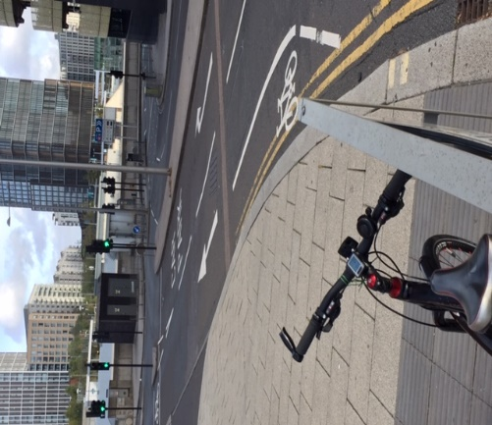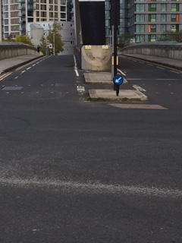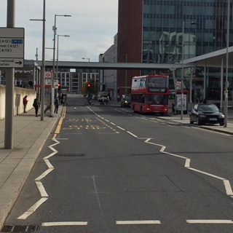
International Way between Westfield Ave and Roundhouse Lane; International way over railway and
International Way between bus stand and Penny Brookes St.
Montfichet Road
Montfichet Rd is a local road designed as a route network route. It should be converted to one lane each way with a 20 mph limit (as in Stratford Town Centre and elsewhere in the QEOP) and unidirectional cycle lanes on each side of the road. Remove central reservation and barriers. This would allow pavement to be pedestrian only and provide space for improved public realm.
At junction with International Way provide a toucan crossing and shared use pavement (accessed by drop kerbs) to facilitate right turn into International Way from Montfichet Rd Rd and from International Way into Montfichet Rd.
Make pedestrian and cycle access where Montfichet Rd touches Carpenters Rd

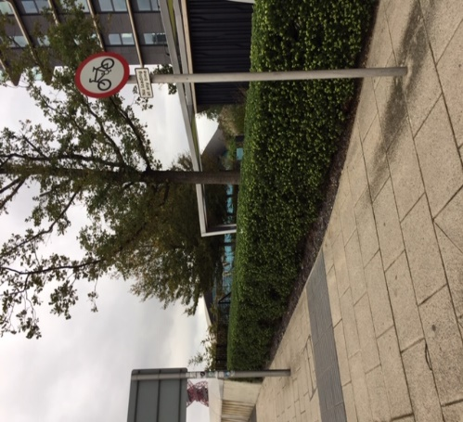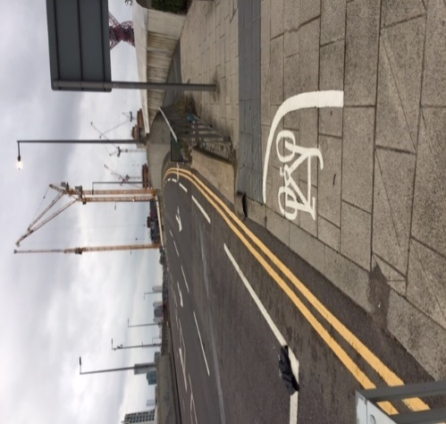
Montfichet Rd approaching Westfield Ave

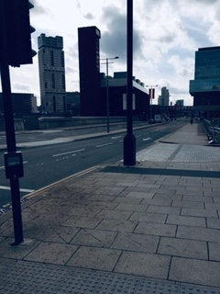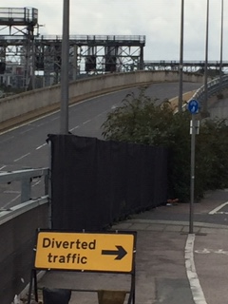
Montfichet Rd from Penny Brooks St to Westfield Ave and Montfichet Rd touching Carpenters Rd
Waterden Rd between Olympic Park Ave and International Way
Remove central reservation and one forward lane to create segregated unidirectional cycle tracks on each side of the road. This allows replacement of poor cycle track on pavement and creates more space for pedestrians and public realm. Provision to allow those on bikes to continue forward from Waterden Road to Westfield Ave without a left hook.

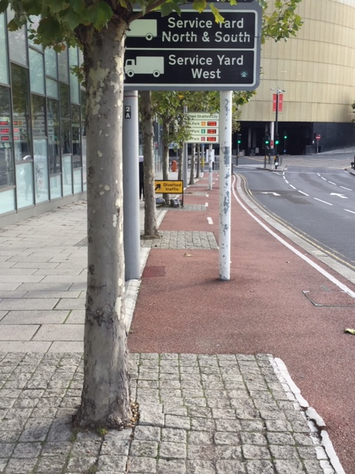
Poor cycle track on pavement at Waterden Rd

Junction Carpenters Rd, Waterden Rd and Warton Rd
Remove roundabout and provide a priority pinch point for cars with a cycle bypass under the railway bridge

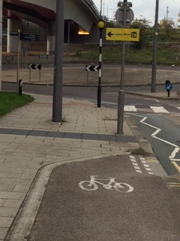

Roudabout Montfichet Road and Warton Road

